

**CPCS241-Database I-Spring2019-Project**

**Erwaa Projects System**

DB Design

**Group No: 12**

|  |  |
| --- | --- |
| Student Name | Student Number |
| Reem Abdulrahman Khalil |  |
| Shahad Saeed Geddan |  |
| Raghad Saad Al-Ghamdi |  |
| Wejdan Mohammed Alshareef |  |

Contents

**PART I: Analysis** 4

1 Problem Definition and Data Requirements 4

1.1 Problem Description 4

1.2 Data Requirements 4

1.3 Business Rules 5

1.4 Intended Output of the system 5

**PART II: DB DEISGN** 6

2 ER Diagram Design 6

2.1 ER diagram 6

2.2 Design of Business Rules 7

3 ER-to-logical schema mapping 8

3.1 Mapping of Regular Entity Types 8

3.2 Mapping of Weak Entity Types 11

3.3 Mapping of binary 1-1 relationship types 12

3.4 Mapping of binary 1-N relationship types 12

**3.5** Mapping of binary M-N relationship types 14

3.6 Mapping of multivalued attributes 16

3.7 Mapping of n-ary relationship types 16

3.8 Schema Diagram 17

4 Normalization……… 18

Functional dependencies 18

4.1 First Normal Form 19

4.2 Second Normal Form 19

4.3 Third Normal Form 19

5 Final DB Schema Diagram 20

PART III: IMPLEMENTATION 21

6 Table Creation Script 21

6.1 < *EMPLOYEE* > TABLE 21

9.2 < *PROJECT* > TABLE 21

9.3 < *WORKS_ON* > TABLE 22

9.4 < *Department* > TABLE 22

9.5 < *Funder_company* > TABLE 22

6.6 < *Representative* > TABLE 23

6.7 < Funds > TABLE 23

6.8 < *Bank_Acount* > TABLE 23

6.9< *Executive_company* > TABLE 24

6.10 < *Project_bankAccount* > TABLE 24

6.11 < STAGES > TABLE 24

7 Constraints Script 25

8 Queries 26

8.1 *<A representative who represents more than one project>* 26

8.2 *<* E*xpected and* actual finish date of projects *>* 27

8.3 *<* E*xpected and* actual cost of projects *>* 27

8.4 *<* *Funder company/companies of* finished projects *>* 28

8.5 *< Funder companies of projects except ‘*Makkah’ projects *>* 29

8.6 *<* *Work hours of each* employee *>* 30

APPENDIX 31

**PART I: Analysis**

# 1 Problem Definition and Data Requirements

## Problem Description

Water shortage is a life-threatening risk people face in certain parts of the world, it directly affects economic, social, political and environmental aspects of their lives.

The solution to this type of problem is complicated and could take years in research and implementation, one of the best solutions is Charitable organizations, for example, the charity Erwaa Association. Erwaa aims to on increasing the quality of life for areas in need by offering many types of water services in Saudi Arabia.

They also work on raising awareness in society by hosting events and encouraging donations to their projects, because of how many projects they work on concurrently and the amount of donations, donors, sponsors and other charities they deal with on a daily basis, a database system for their association is a must that will help increase their productivity and organize their work.

## Data Requirements

1. The association can work on multiple projects, each project has the following data: id, name, location (region, province and city) , project budget (estimated cost) , expected start and finish dates , implementation stages, bank account, the employee who worked on this project and number of its working hours , the funder (supporting entity) and state of the project (finished or in progress).
2. Each Employee has a unique national ID number, name, date of birth , salary ,and the notes.
3. There are 3 departments, each department has id, name, manager, employees, No. of employees.
4. Project shareholders are individuals (donors) , or the funder.
5. The funder is another charity , ministry or charitable waqf ,each funder has the following data: id , name, representative to them and funded money.
6. Eeach representative has : id , name and contact number.
7. Erwaa’s bank account has the : id , IBAN and name.
8. Each Implementation stage of the project has : id , name , cost , start and finish date and it’s executive company.
9. Executive company has : id , name and contact number.

## Business Rules

1. Each employee must work for only one department.
2. Each department must have unique name.
3. A single bank account can be used for more than one project.
4. The funder can have more one representative (such as, representative for each

project).

1. In a singhe project , the funder must have one representative.
2. The contact number of the Representative must be not null.
3. Each Funder can sport more one project at a time.
4. The executive company can implement more than one stage, but the one stage implemented by one company only.
5. The cost of the one stage must be <=50000000.

## Intended Output of the system

The system should be designed such that the database should produce reports such as:

1. Print representative name, representative contact number, and the name of Funder company which he works for it (if he represents two or more project ).
2. For each project print project names ,project expected finish date and project actual finish date.
3. For each project print project names ,project expected cost and project actual cost.
4. For each finished project print Funder company*/companies* Name and its total funds.
5. Print the ID and Name of each Funder Company that Funds a project not in ‘Makkah’ city .
6. For each employee, print the NationalID, employees’ firstName and LastNames, and the total number of its work hours, (include even employees who did works on project).

# PART II: DB DEISGN

# 2 ER Diagram Design

## 2.1 ER diagram

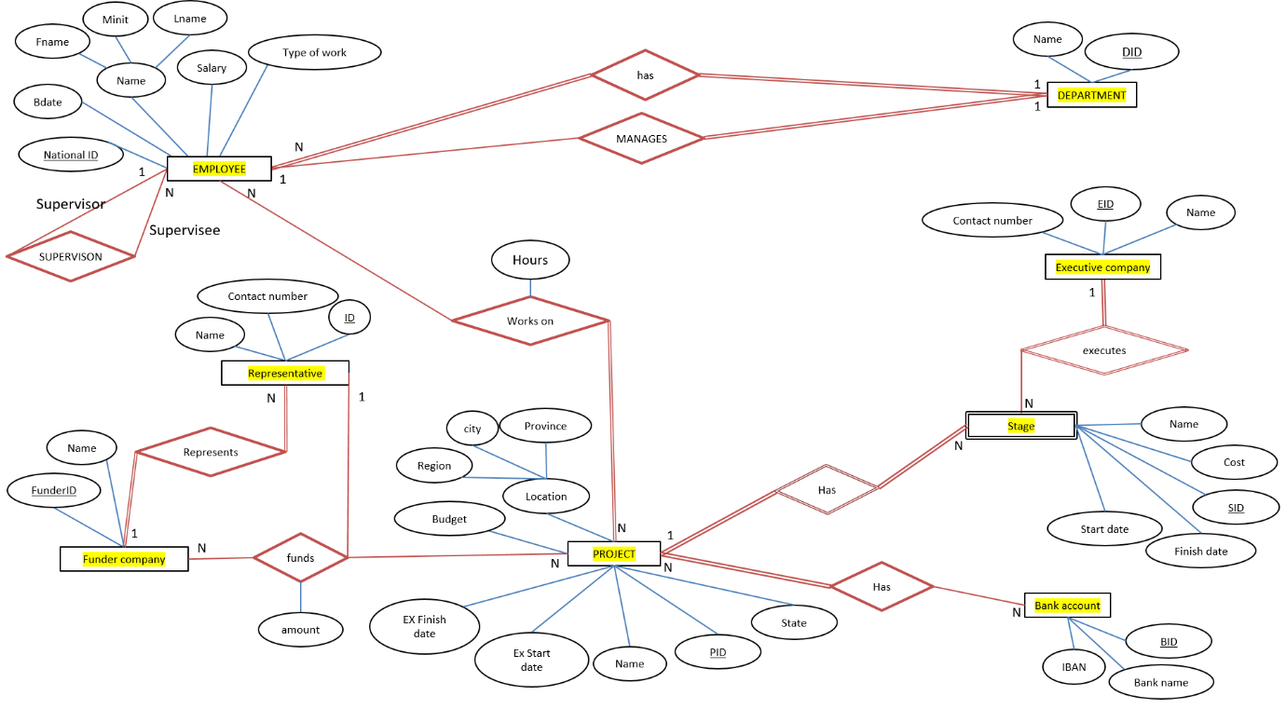

**Notes**

# 

# 

## 2.2 Design of Business Rules

|  |  |  |
| --- | --- | --- |
| Business rule | Design decisions | Justification (if any) |
| Each employee must work for only one department | A 1-N, full-participation relation between employee and department |  |
| The Funder can sport more one project at a time. | - |  |
| The funder can have more one representative (such as, representative for each  project). | A 1-N, full-participation relation between Funder and Representative | To add more flexibility to the system |
| Each department must have UNIQUE name. | - | We can do it in implementation time not here. |
| The cost of the one stage must be <=50000000. | - | We can do it in implementation time not here. |
| The contact number of the Representative must be not null. | - | We can do it in implementation time not here. |

# ER-to-logical schema mapping

## 3.1 Mapping of Regular Entity Types

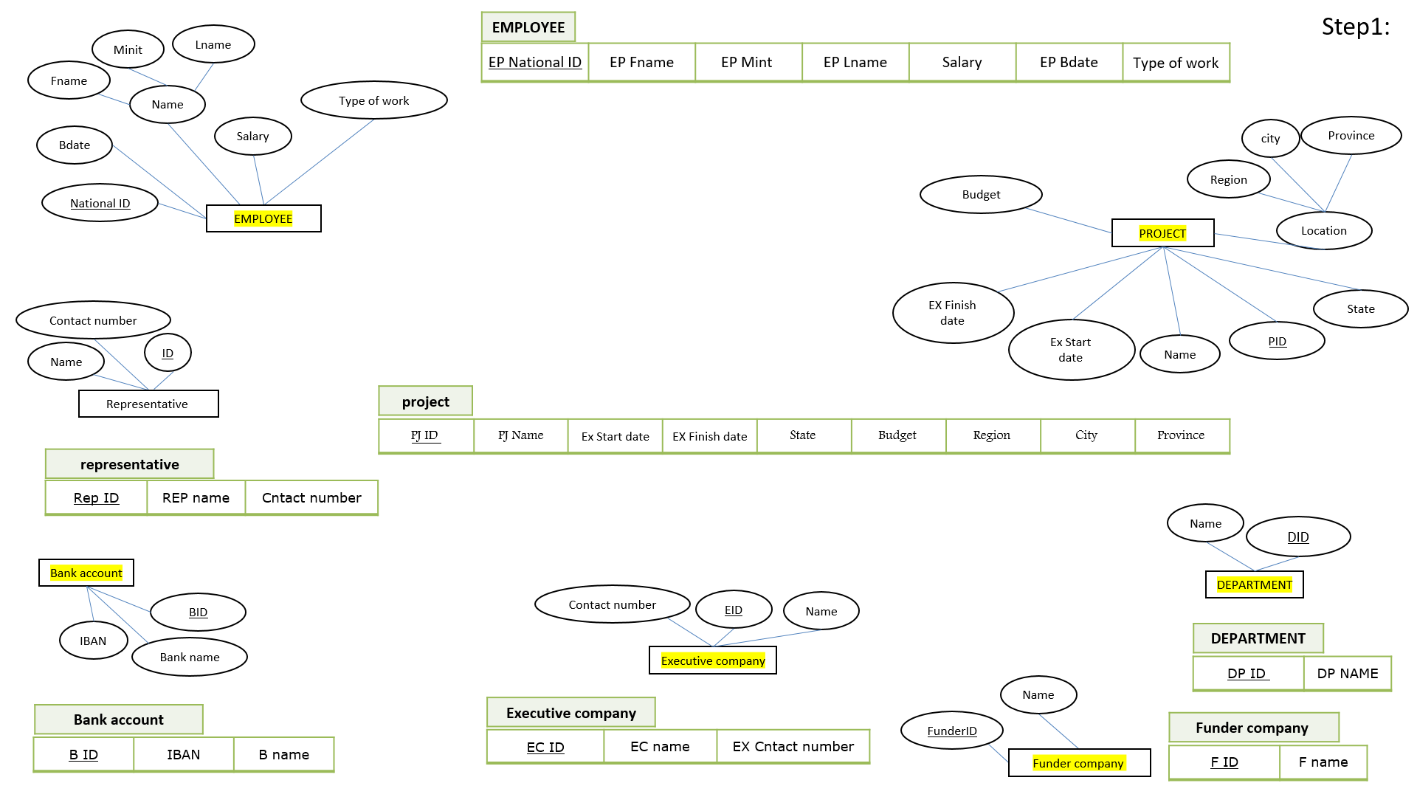

**Notes**

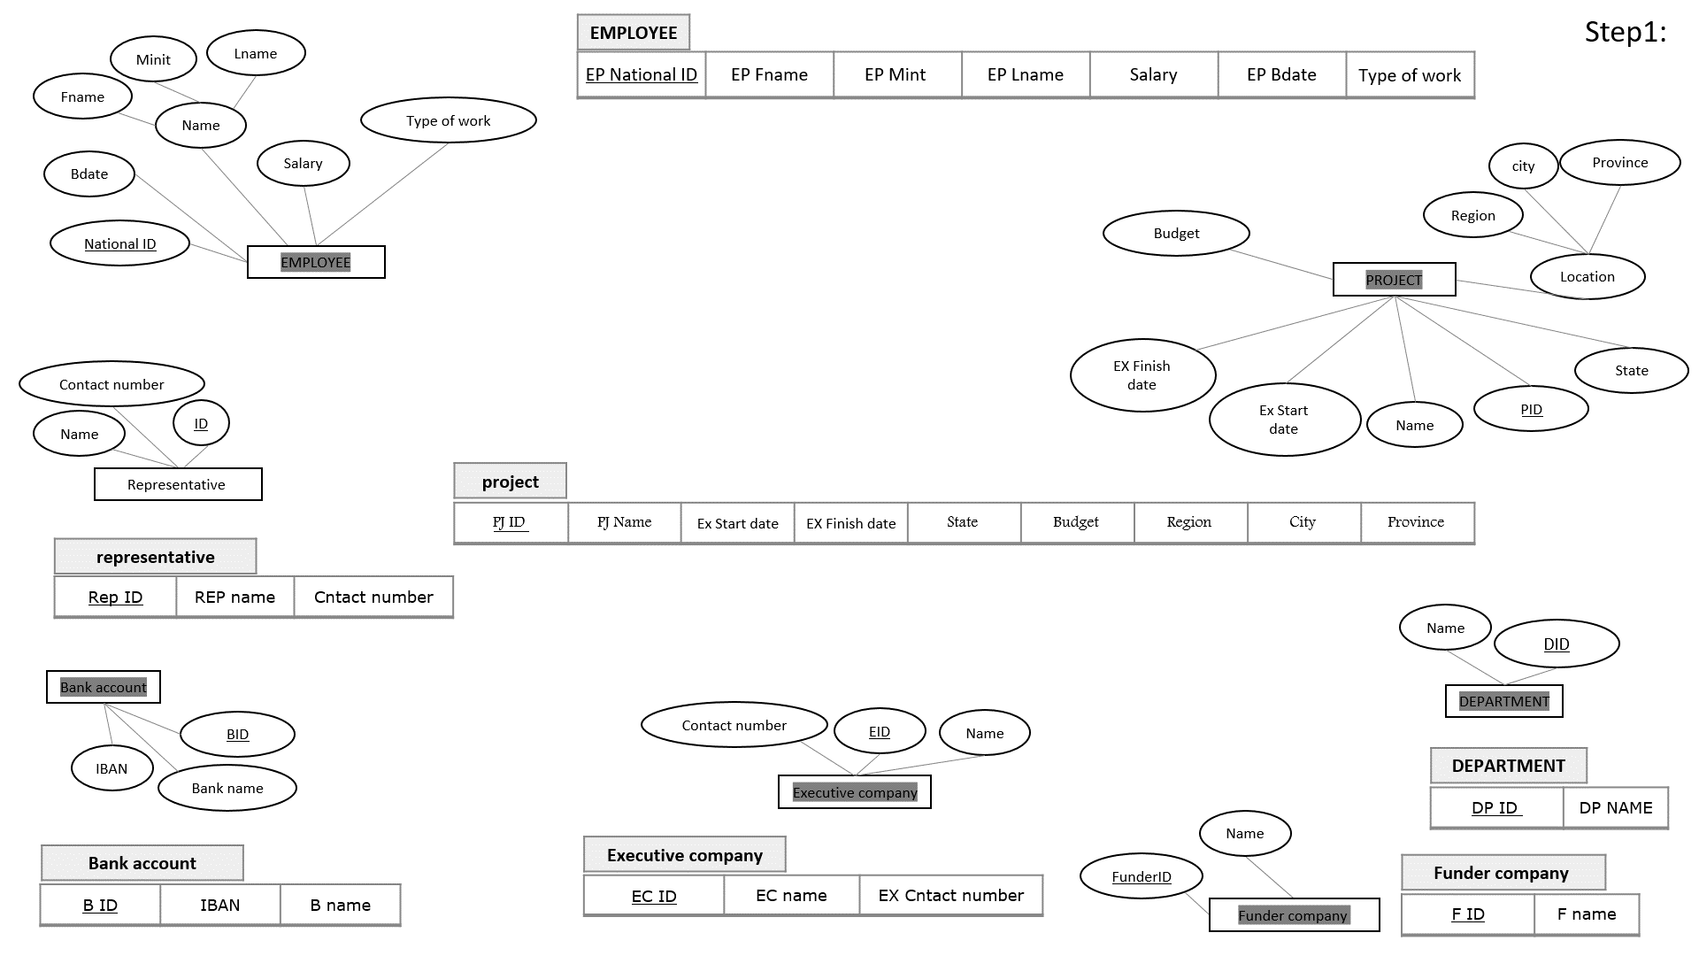

**Notes**

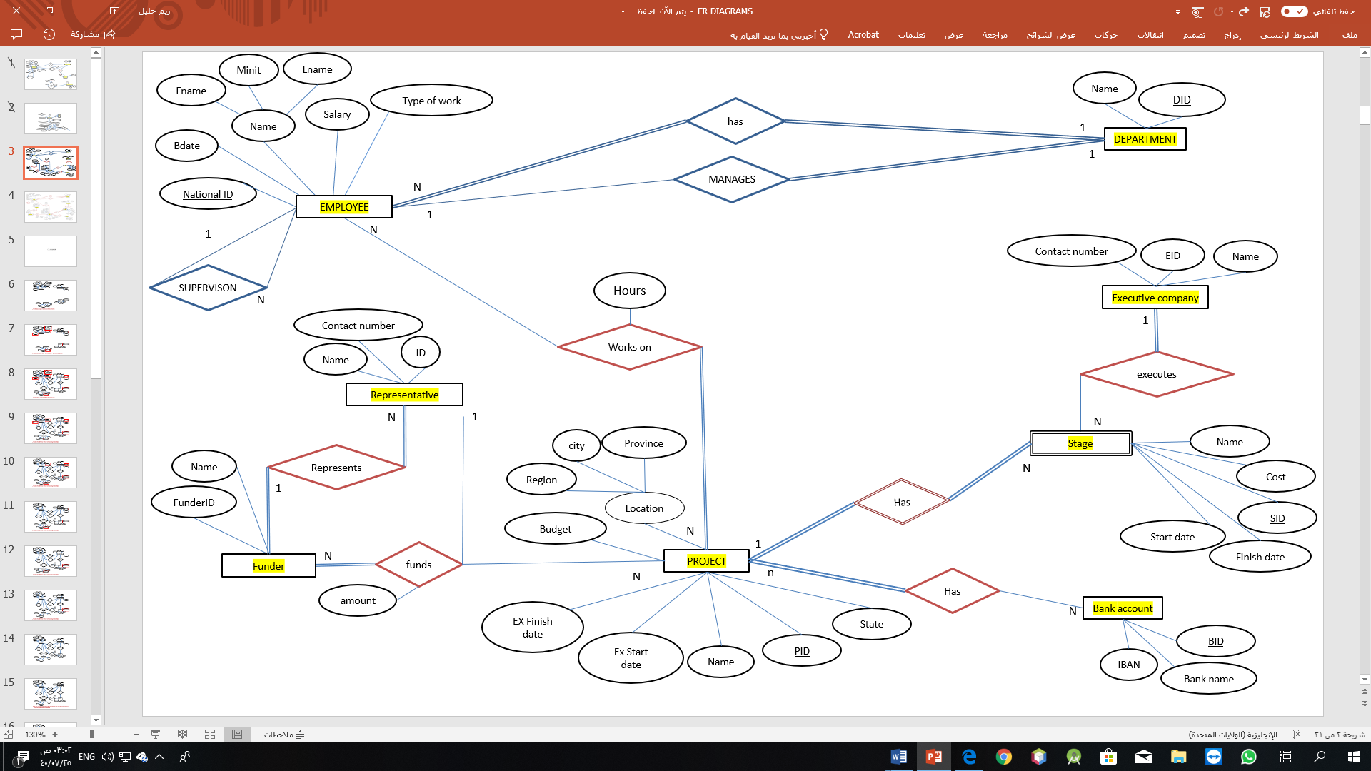























**3.2 Mapping of Weak Entity Types**

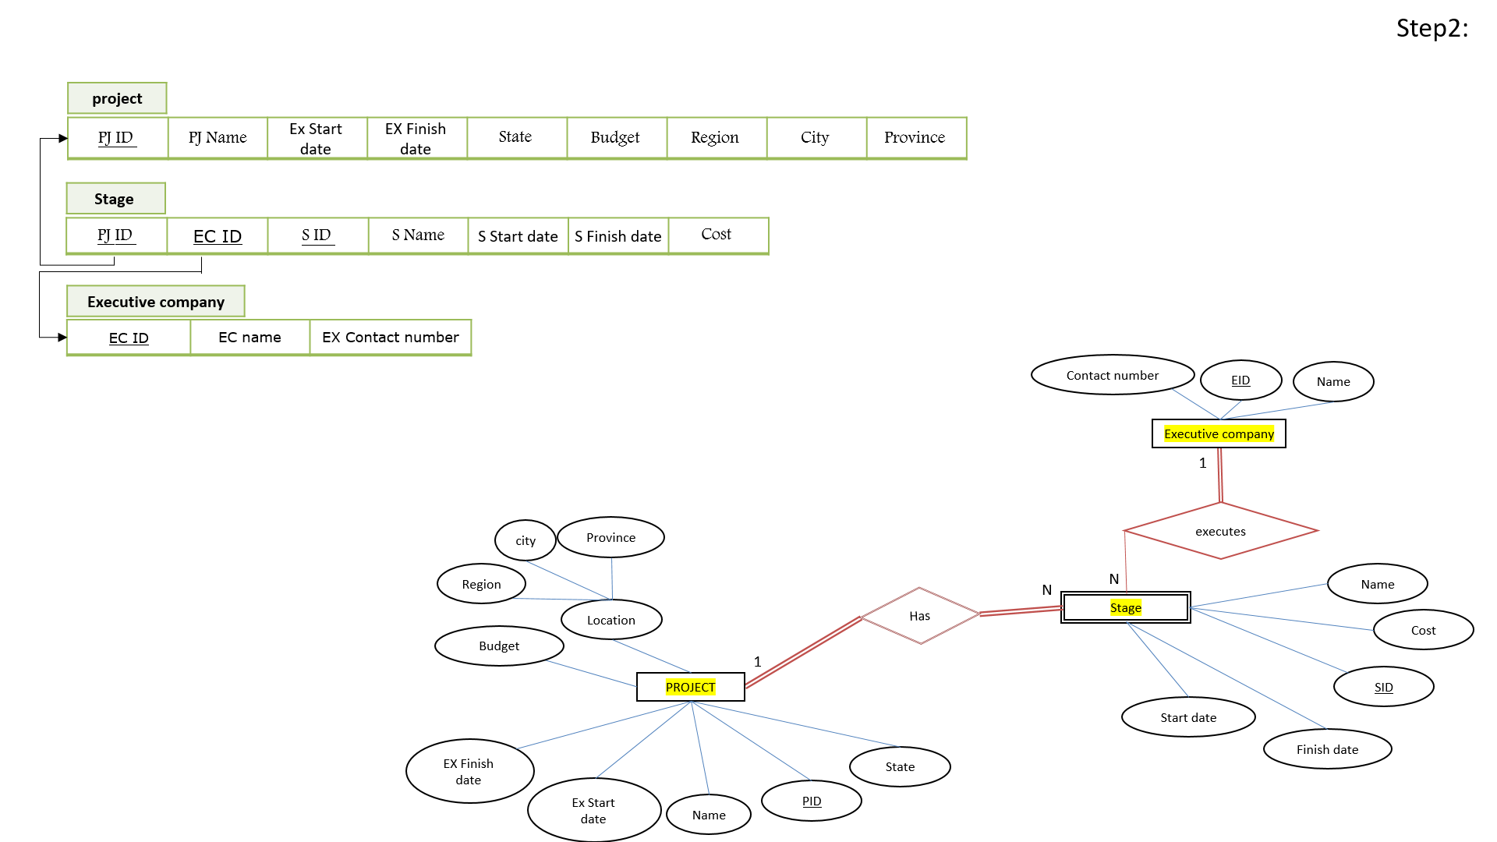



## 3.3 Mapping of binary 1-1 relationship types

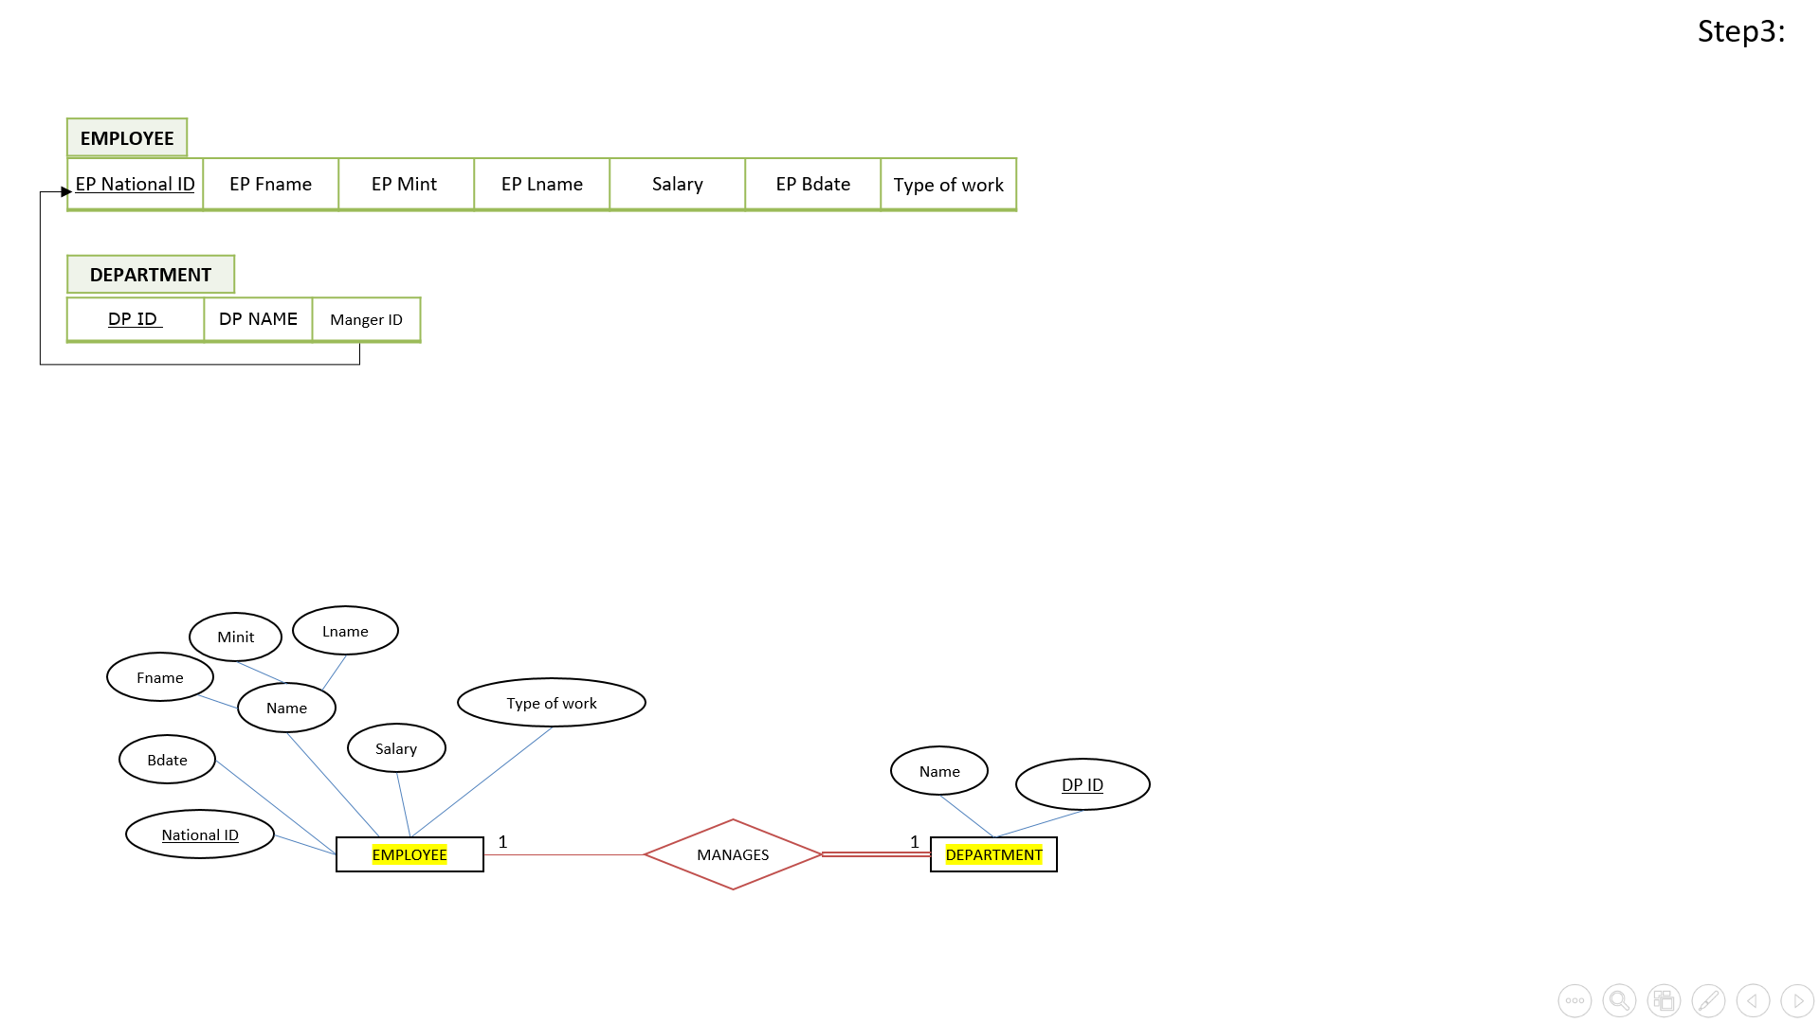

**Notes**



**Notes**

## 3.4 Mapping of binary 1-N relationship types

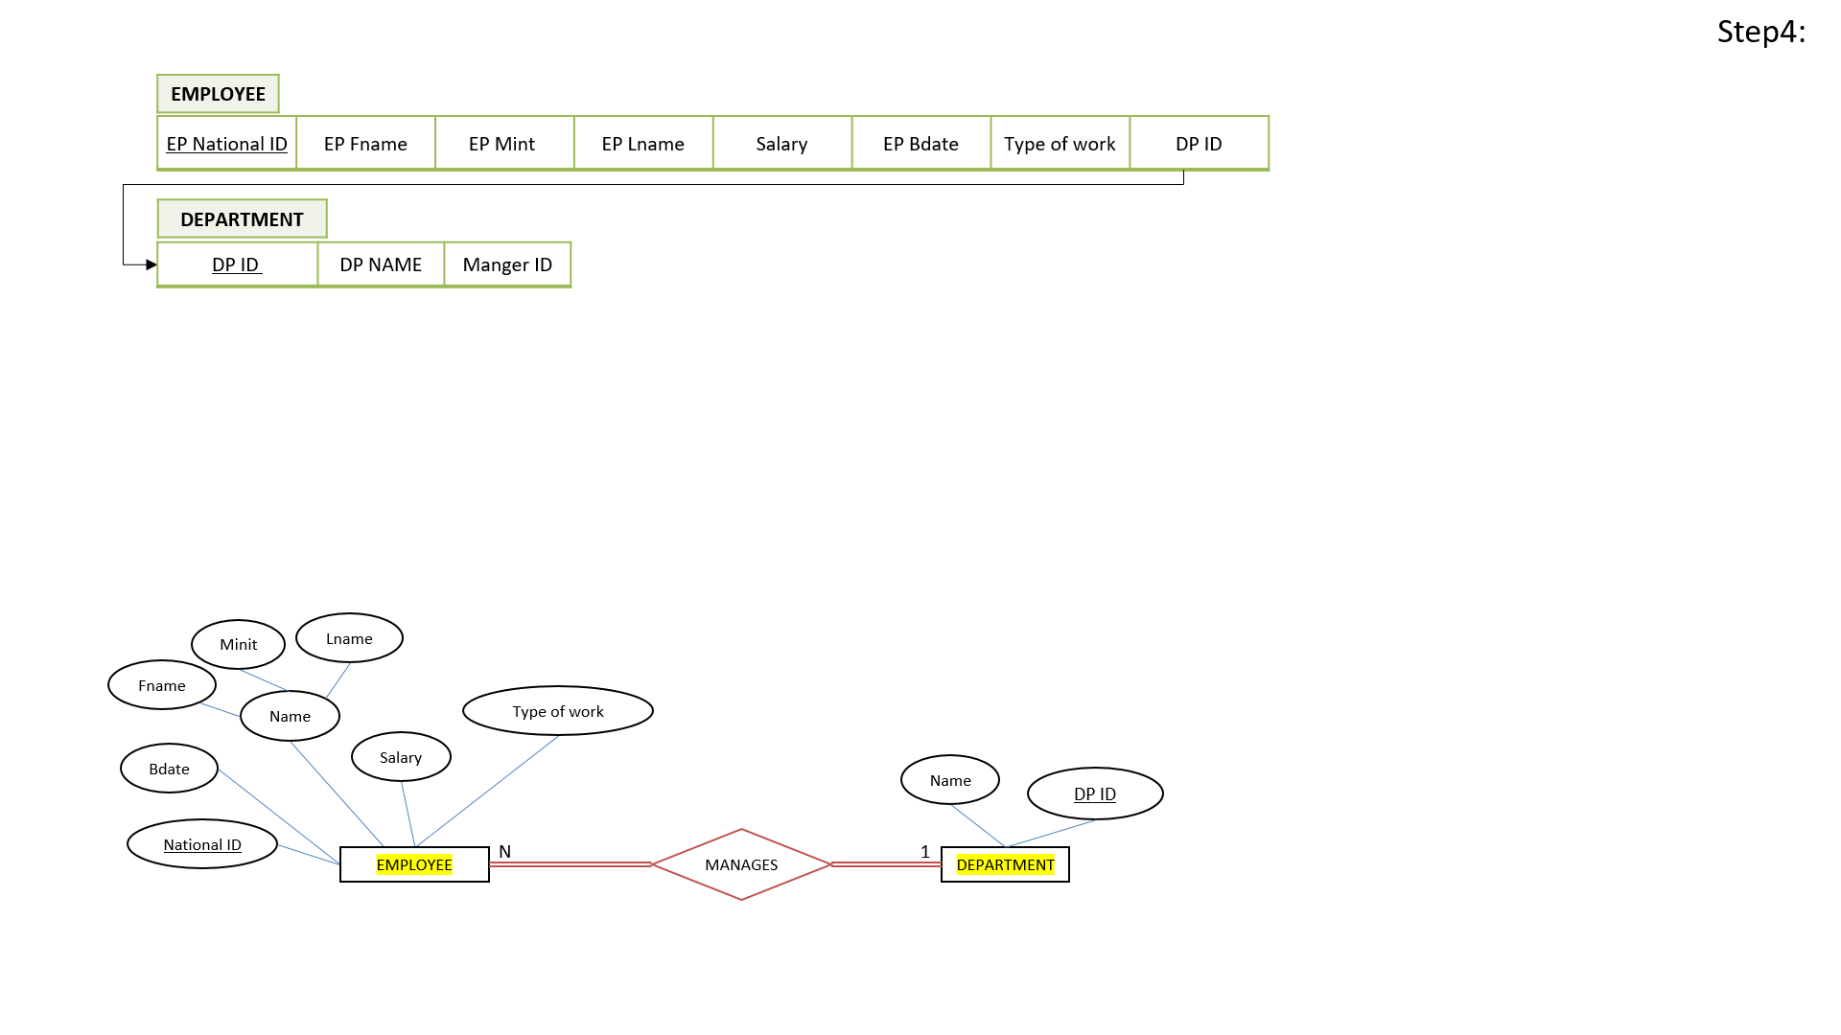

**Notes**



**Notes**

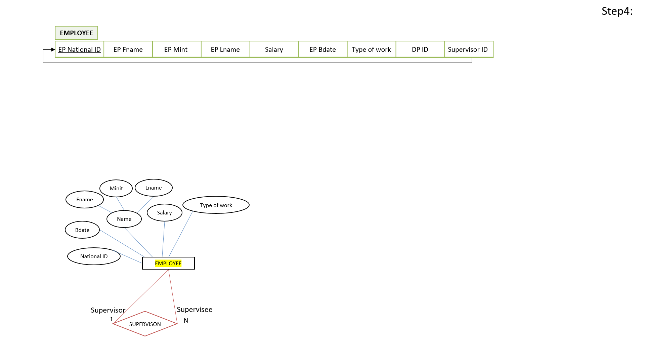

**Notes**



**Notes**

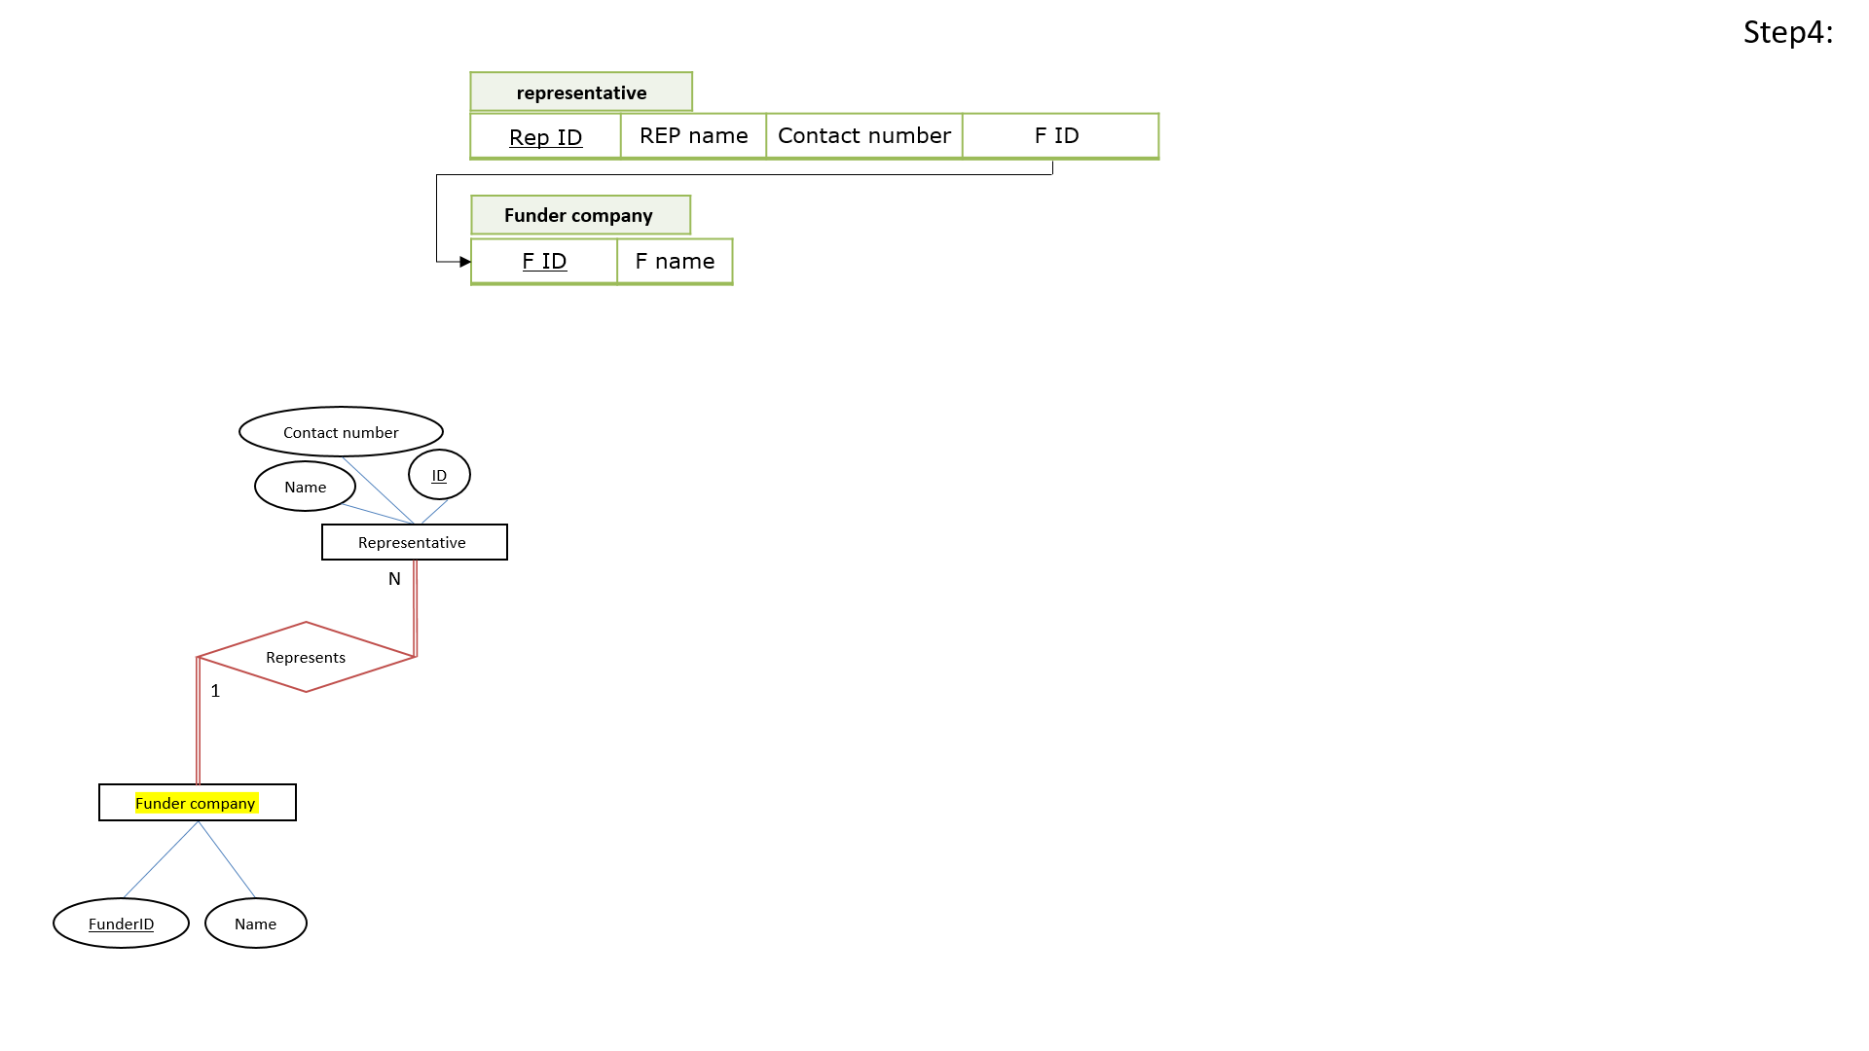



**3.5 Mapping of binary M-N relationship types**

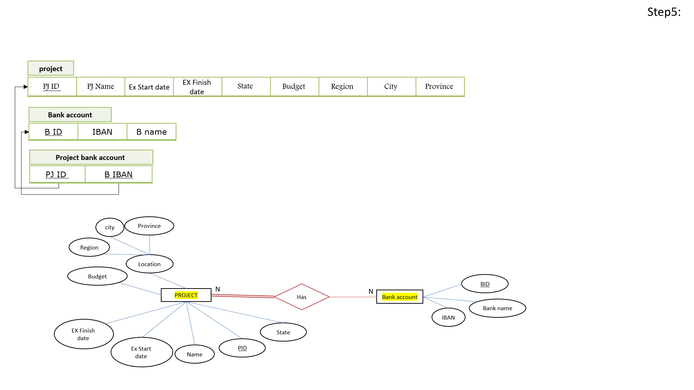

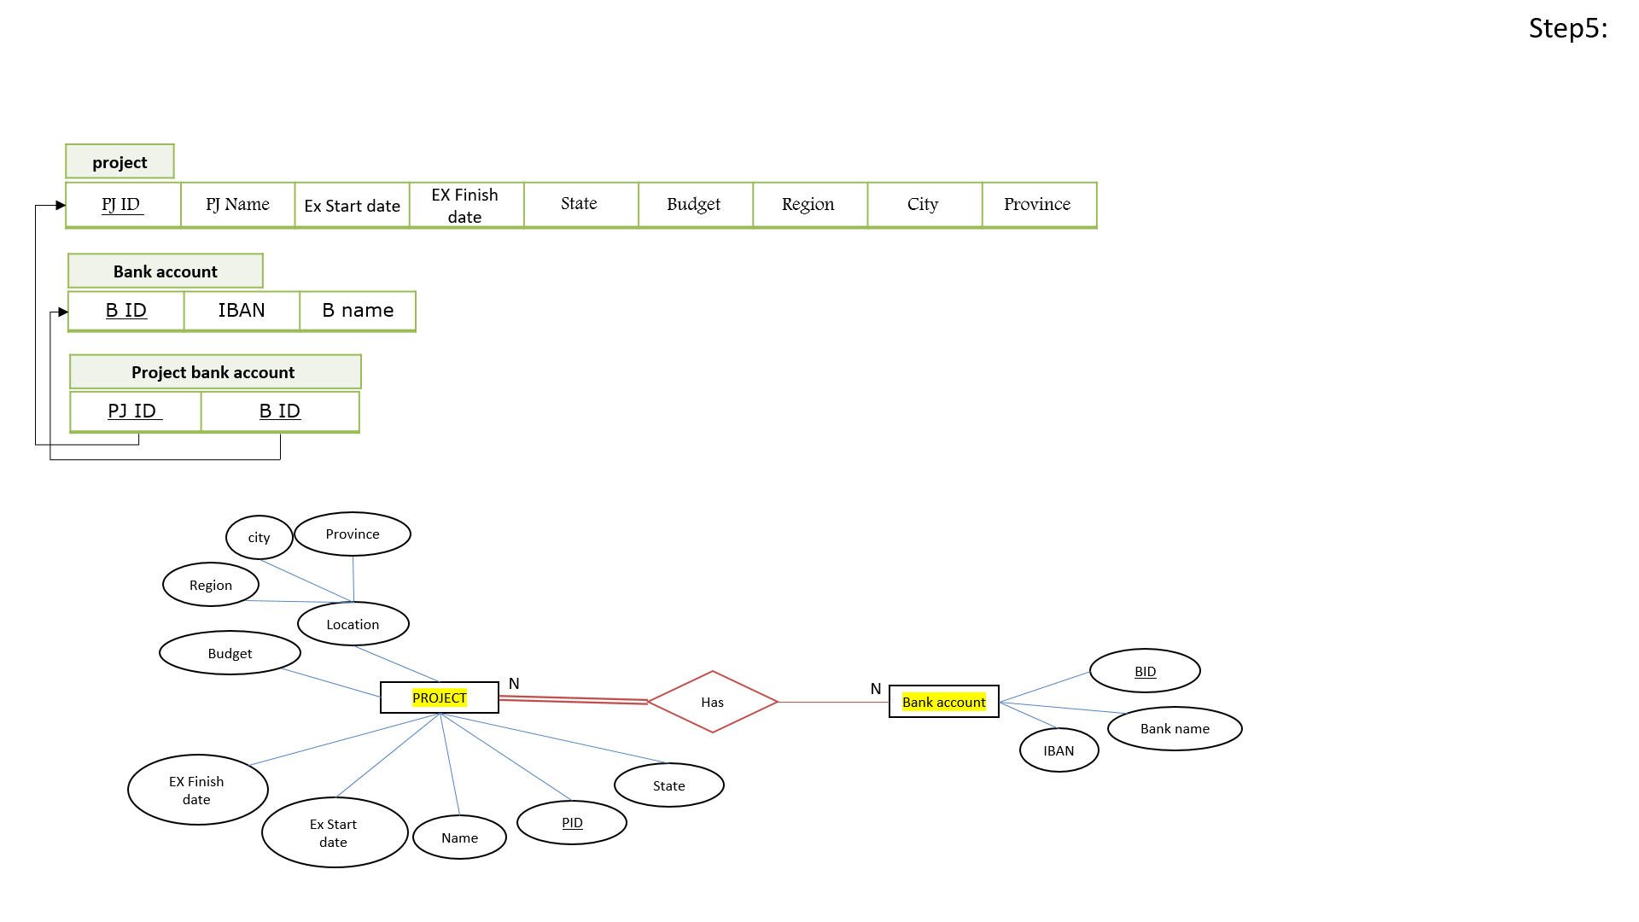

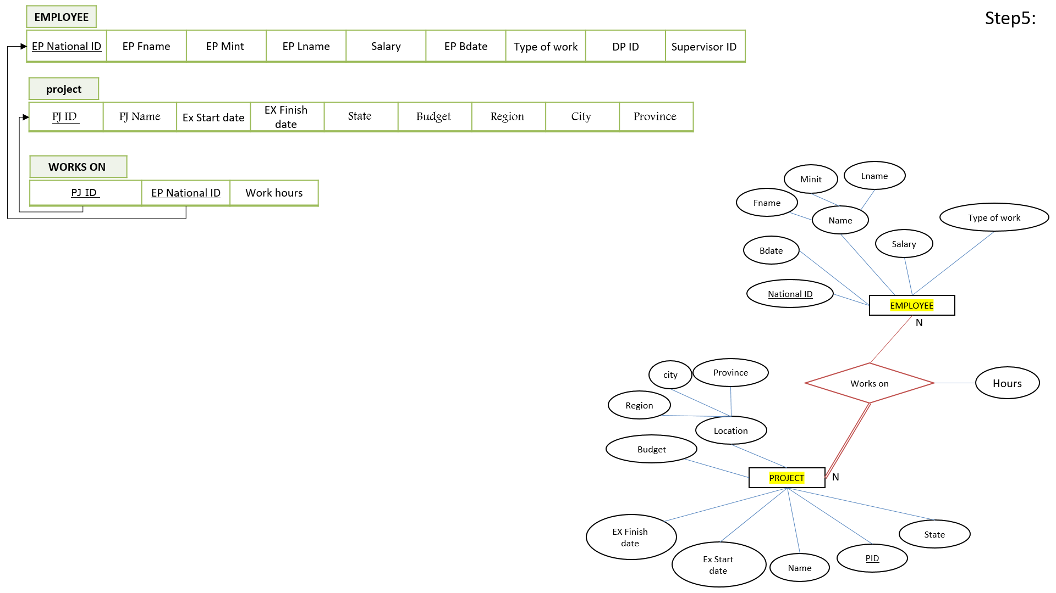

**Notes**



**Notes**

## 

## 3.6 Mapping of multivalued attributes

The ER does not have multivalued attributes.

## 3.7 Mapping of n-ary relationship types

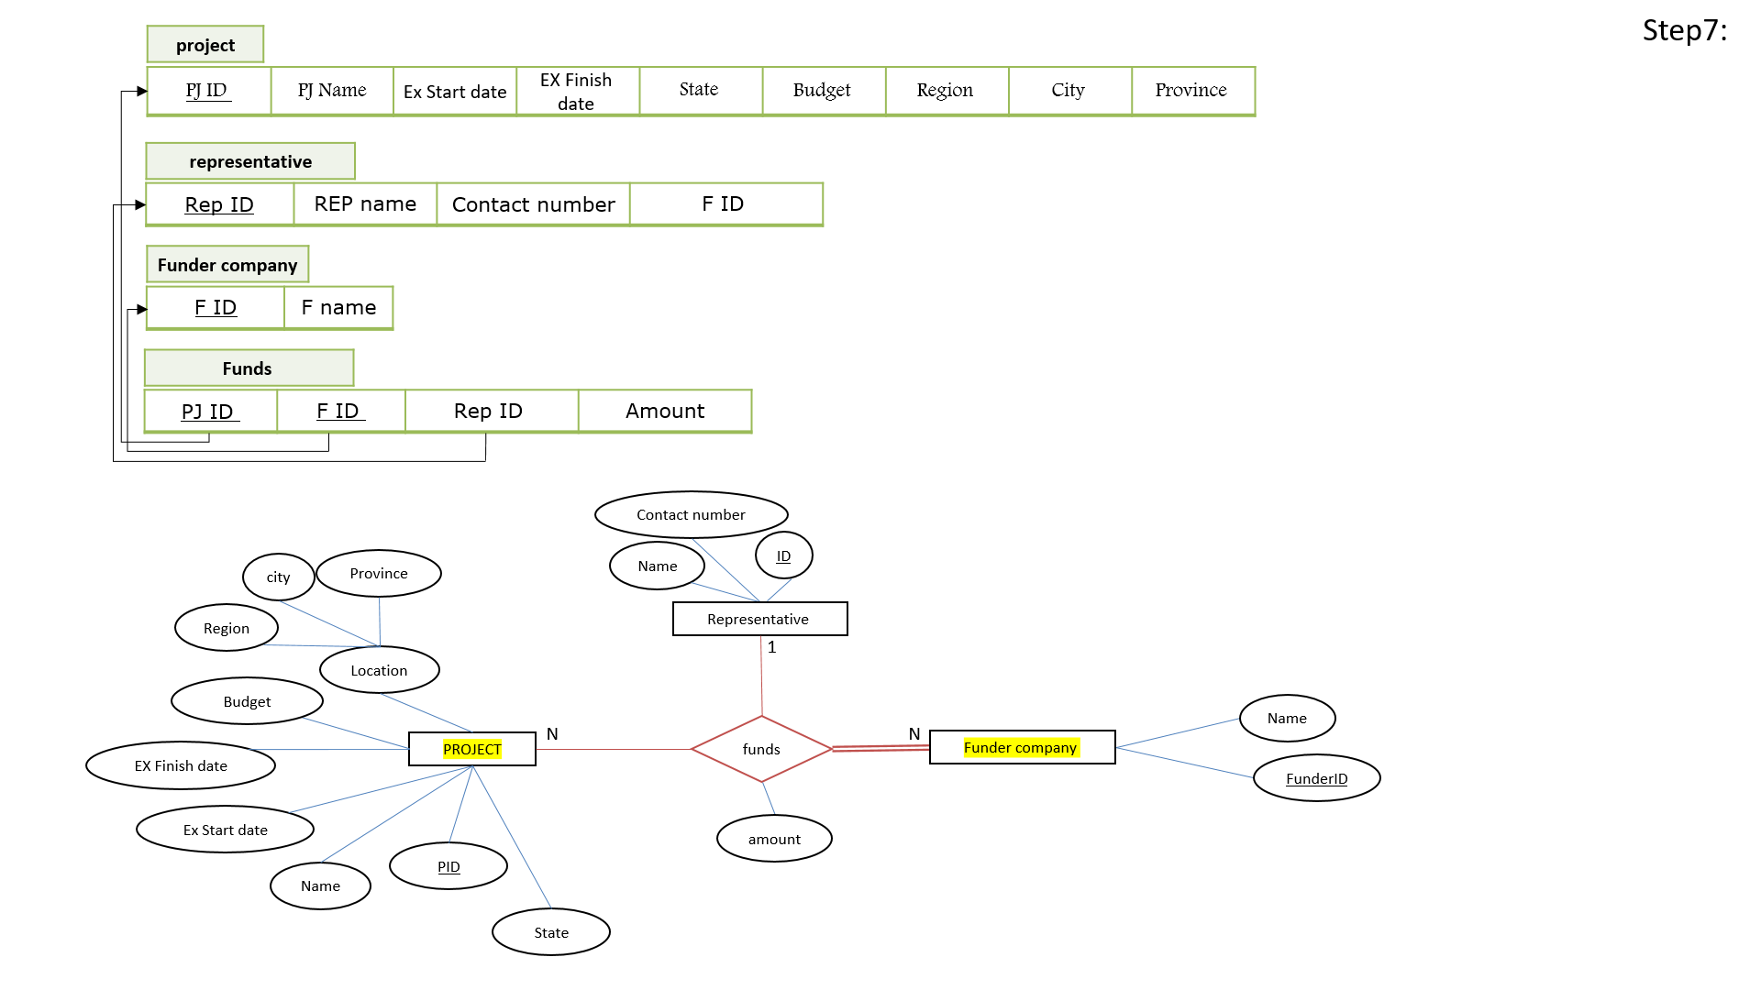



## 3.8 Schema Diagram

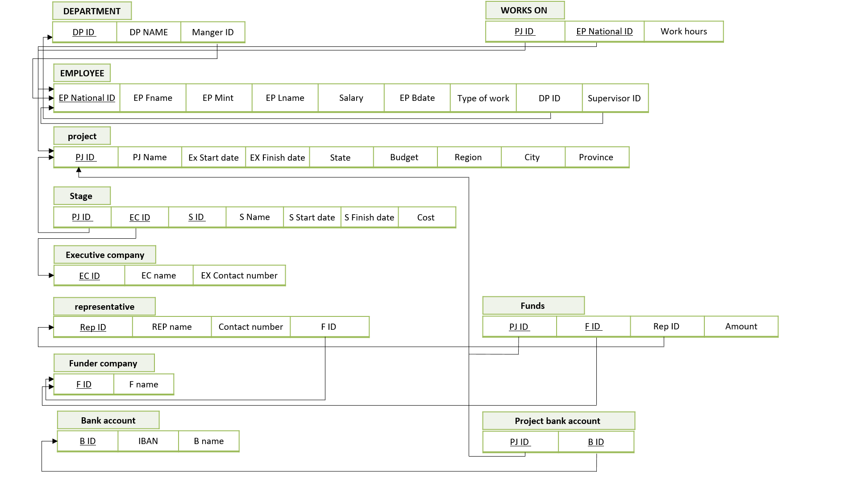

**Notes**

# Normalization

# Functional dependencies

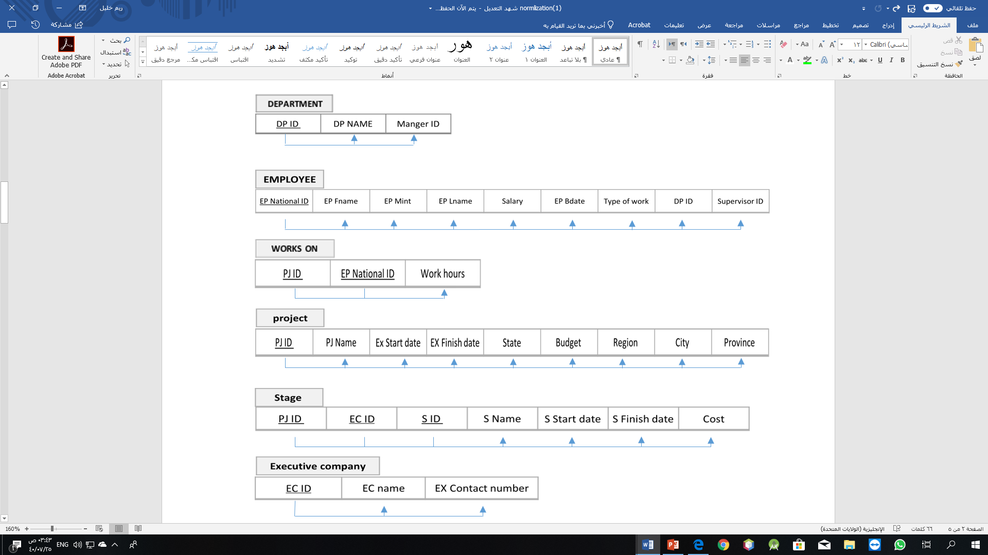

**Notes**

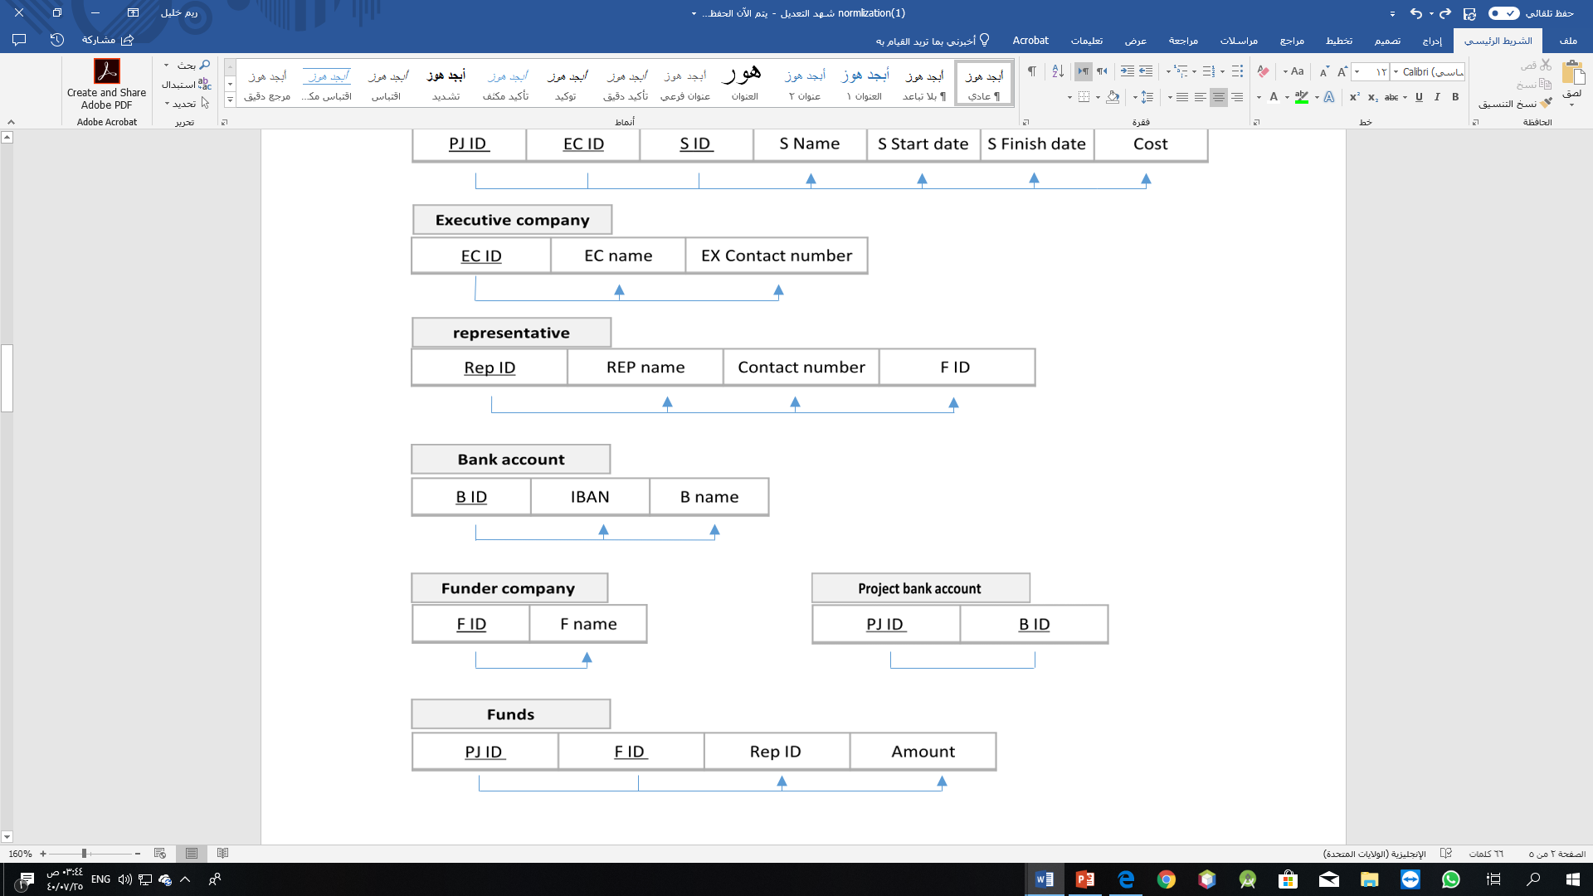

## 4.1 First Normal Form

All tables are in 1NF

Reason: there is no multivalued attributes or nested relation in our schema

(All the attributes are atomic).

## 4.2 Second Normal Form

All tables are in 2NF

Reason: all tables are in 1NF and there is no partial functional dependency

## 4.3 Third Normal Form

All tables are in 3NF

Reason: all tables are in 1NF & 2NF and there is no transitive functional dependency on PK PK

# 5 Final DB Schema Diagram

Same the Schema Diagram.



**Notes**

# PART III: IMPLEMENTATION

# 6 Table Creation Script

## 6.1 < *EMPLOYEE* > TABLE

CREATE TABLE EMPLOYEE(

NationalID NUMBER(10) PRIMARY KEY ,

Fname VARCHAR2(20) NOT NULL ,

Mint VARCHAR2(20),

Lname VARCHAR2(20) ,

Salary NUMBER(10),

Bdate DATE ,

NOTE VARCHAR2(225),

DPID NUMBER(10),

SupervisorID NUMBER(10) );

alter table EMPLOYEE

add CONSTRAINT EMPSUPERFK FOREIGN KEY (SupervisorID) REFERENCES EMPLOYEE (NationalID)

add CONSTRAINT DP_ID FOREIGN KEY (DPID) REFERENCES department (DP_ID);

*Note: We added the CONSTRAINT after insertion commands so, we used the (alter).

## < *PROJECT* > TABLE

CREATE TABLE PROJECT(

PJ_ID NUMBER(10) PRIMARY KEY ,

PJ_name VARCHAR2(20) NOT NULL ,

Ex_startDate DATE,

Ex_finishDate DATE,

state VARCHAR2(20),

Budget NUMBER(20) ,

Region VARCHAR2(20),

City VARCHAR2(20),

Province VARCHAR2(20));

## < *WORKS_ON* > TABLE

CREATE TABLE WORKS_ON(

Works_hours NUMBER(10),

ProjectID NUMBER(10) ,

NationalID NUMBER(10) ,

CONSTRAINT WORKONPK PRIMARY KEY(ProjectID,NationalID) );

alter table WORKS_ON

add CONSTRAINT PROIDFK FOREIGN KEY (ProjectID) REFERENCES PROJECT(PJ_ID)

add CONSTRAINT EMPIDFK FOREIGN KEY (NationalID) REFERENCES EMPLOYEE(NationalID);

## < *Department* > TABLE

CREATE TABLE Department(

DP_ID NUMBER(10) PRIMARY KEY ,

DP_name VARCHAR2(20) UNIQUE ,

Manger_ID NUMBER(10) );

alter table Department

add CONSTRAINT MIDFK FOREIGN KEY (Manger_ID) REFERENCES EMPLOYEE(NationalID);

## < *Funder_company* > TABLE

CREATE TABLE Funder_company (

F_ID number(10) PRIMARY KEY,

F_name varchar2(32) );

## 6.6 < *Representative* > TABLE

CREATE TABLE representative(

Rep_ID number(10) PRIMARY KEY,

Rep_Name varchar2(50),

contactNum number(10) NOT NULL ,

FunderID number(10) );

alter table representative

add CONSTRAINT FCIDFK FOREIGN KEY (FunderID) REFERENCES Funder_company (F_ID) ;

## 6.7 < Funds > TABLE

CREATE TABLE Funds (

Project_ID number(10) ,

F_ID number(10) ,

amount number(10),

Rep_ID number(10),

CONSTRAINT FOUNDSPK PRIMARY KEY( Project_ID , F_ID ) );

alter table Funds

add CONSTRAINT REPIDFFK FOREIGN KEY (Rep_ID) REFERENCES representative(Rep_ID)

add CONSTRAINT FCIDFFK FOREIGN KEY (F_ID) REFERENCES funder_company(f_id)

add CONSTRAINT PROIDFFK FOREIGN KEY (Project_ID) REFERENCES project (pj_id);

## 6.8 < *Bank_Acount* > TABLE

CREATE TABLE Bank_Acount (

B_ID number(10) PRIMARY KEY,

B_name varchar(32),

IPAN varchar2(35) UNIQUE );

## 6.9 < *Executive_company* > TABLE

CREATE TABLE Executive_company (

EC_ID number(10) PRIMARY KEY,

EC_name varchar2(32),

Ex_contactNum number(10) NOT NULL );

## 6.10 < *Project_bankAccount* > TABLE

CREATE TABLE Project_bankAccount (

B_ID number(10),

Pj_ID number(10),

CONSTRAINT PBAPK PRIMARY KEY( B_ID , Pj_ID ) );

alter table Project_bankAccount

add CONSTRAINT PIDFK FOREIGN KEY (Pj_ID) REFERENCES project (PJ_ID )

ADD CONSTRAINT BIDFK FOREIGN KEY (B_ID) REFERENCES bank_acount(B_ID);

## 6.11 < STAGES > TABLE

CREATE TABLE STAGES (

Project_ID NUMBER(10) ,

EC_ID NUMBER (10) ,

S_id NUMBER (10),

S_name varchar2(50),

StartDate date,

FinishDate date,

cost number(10) CHECK (cost <=50000000),

CONSTRAINT STAGEPK PRIMARY KEY ( Project_ID , EC_ID , S_id ) );

alter table STAGES

add CONSTRAINT ECIDSFK FOREIGN KEY (EC_ID) REFERENCES Executive_company (EC_ID)

add CONSTRAINT PROIDSFK FOREIGN KEY (Project_ID) REFERENCES project (pj_id);

# 7 Constraints Script

|  |  |  |
| --- | --- | --- |
| Business Rule | SQL Script | Table |
| Each department must have UNIQUE name. | CREATE TABLE Department(  ..  DP_name VARCHAR2(20) UNIQUE  ..); | Department |
| Each employee must work for only one department | CREATE TABLE EMPLOYEE(  …  DPID NUMBER(10),  … );  Alter table Employee  add CONSTRAINT DP_ID FOREIGN KEY (DPID) REFERENCES department (DP_ID); | Employee |
| The Funder can work on more one project at a time. | - | - |
| The funder can have more one representative (such as, representative for each  project). | CREATE TABLE representative(  …  FunderID number(10) );  Alter table representative  add CONSTRAINT FCIDFK FOREIGN KEY (FunderID) REFERENCES Funder_company (F_ID) ; | Representative |
| The cost of the one stage must be <=50000000. | CREATE TABLE STAGES (  …  cost number(10) CHECK (cost <=50000000),  ..); | STAGES |
| The contact number of the Representative must be not null. | CREATE TABLE representative(  …  contactNum number(10) NOT NULL , ...); | Representative |

# 8 Queries

## 8.1 *<**A representative who represents more than one project>*

**Query in natural language (ENGLISH)**

Print representative name, representative contact number, and the name of Funder company which he works for it (if he represents two or more project )

**SQL script**

select representative.Rep_Name ,representative.contactNum ,Funder_company.F_name,count(*) as "PROJECTSNUM"

from project, representative , Funds, Funder_company

where project.PJ_ID=Funds.Project_ID

and representative.Rep_ID=Funds.Rep_ID

and Funder_company.F_ID =Funds.F_ID

group by representative.Rep_Name ,representative.contactNum ,Funder_company.F_name

having count(*)>1 ;

**Caption of the first five rows of the output**

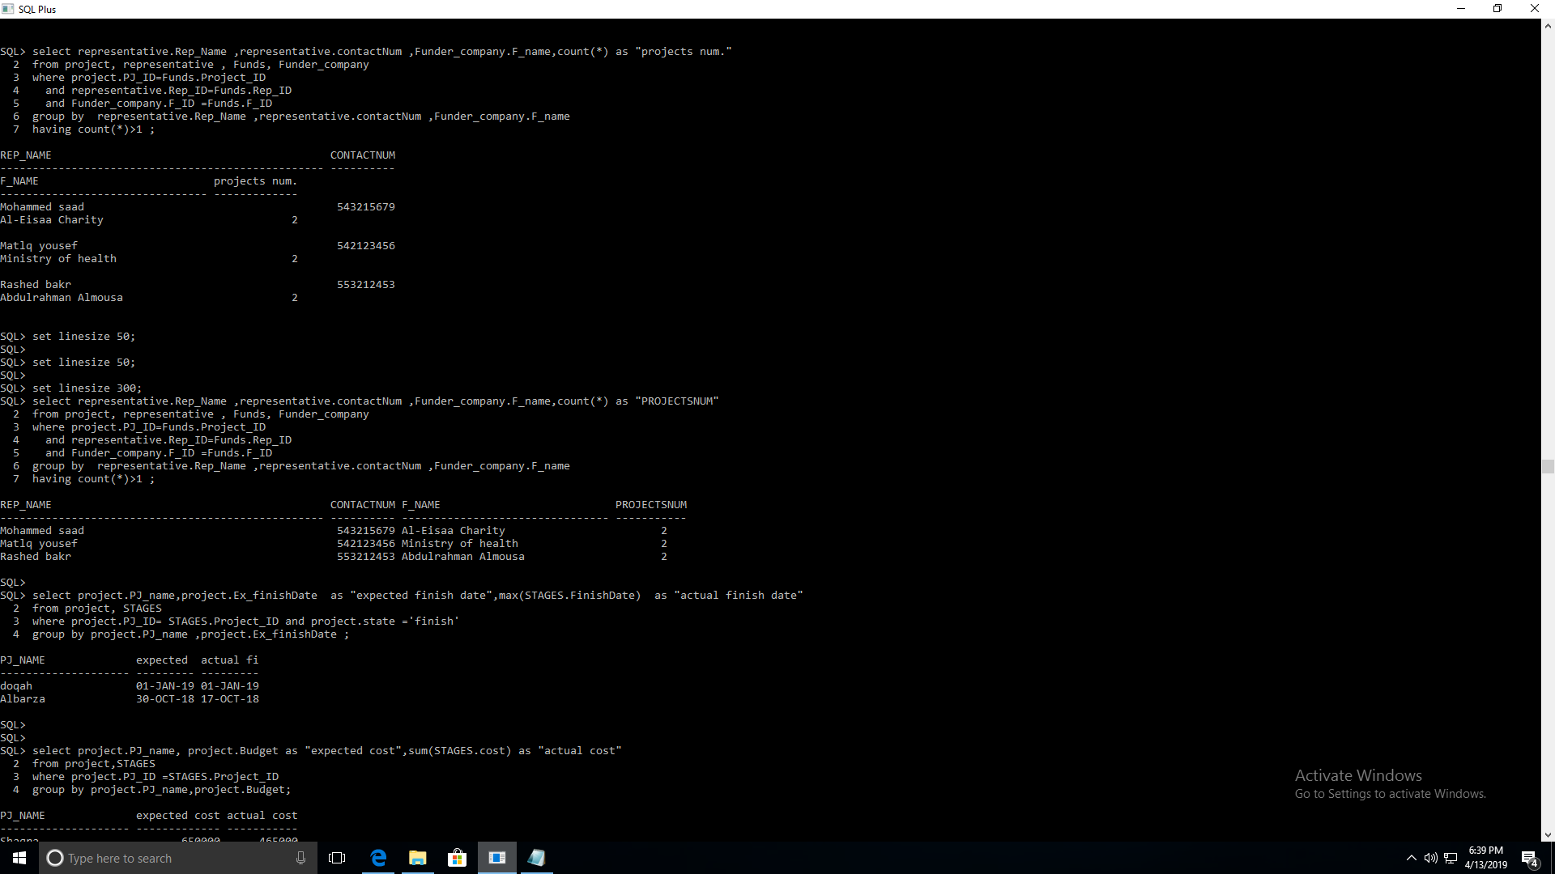

## 8.2 *<* E*xpected and* actual finish date of projects *>*

**Query in natural language (ENGLISH)**

For each project print project names ,project expected finish date and project actual finish date

**SQL script**

select project.PJ_name,project.Ex_finishDate as "expected finish date",max(STAGES.FinishDate) as "actual finish date"

from project, STAGES

where project.PJ_ID= STAGES.Project_ID and project.state ='finish'

group by project.PJ_name ,project.Ex_finishDate ;

**Caption of the first five rows of the output**

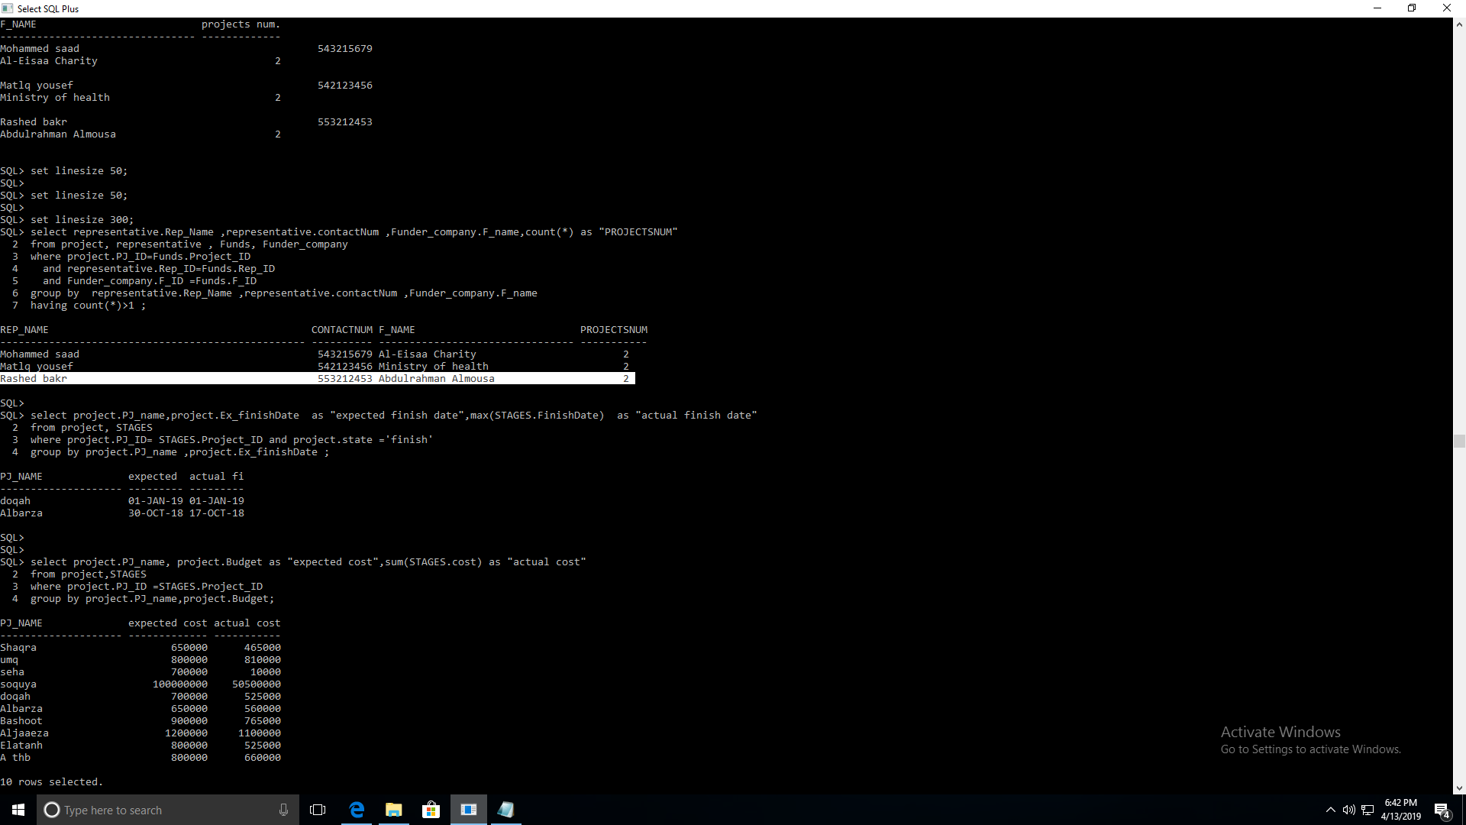

## 8.3 *<* E*xpected and* actual cost of projects *>*

**Query in natural language (ENGLISH)**

For each project print project names ,project expected cost and project actual cost

**SQL script**

select project.PJ_name, project.Budget as "expected cost",sum(STAGES.cost) as "actual cost"

from project,STAGES

where project.PJ_ID =STAGES.Project_ID

group by project.PJ_name,project.Budget;

**Caption of the first five rows of the output**

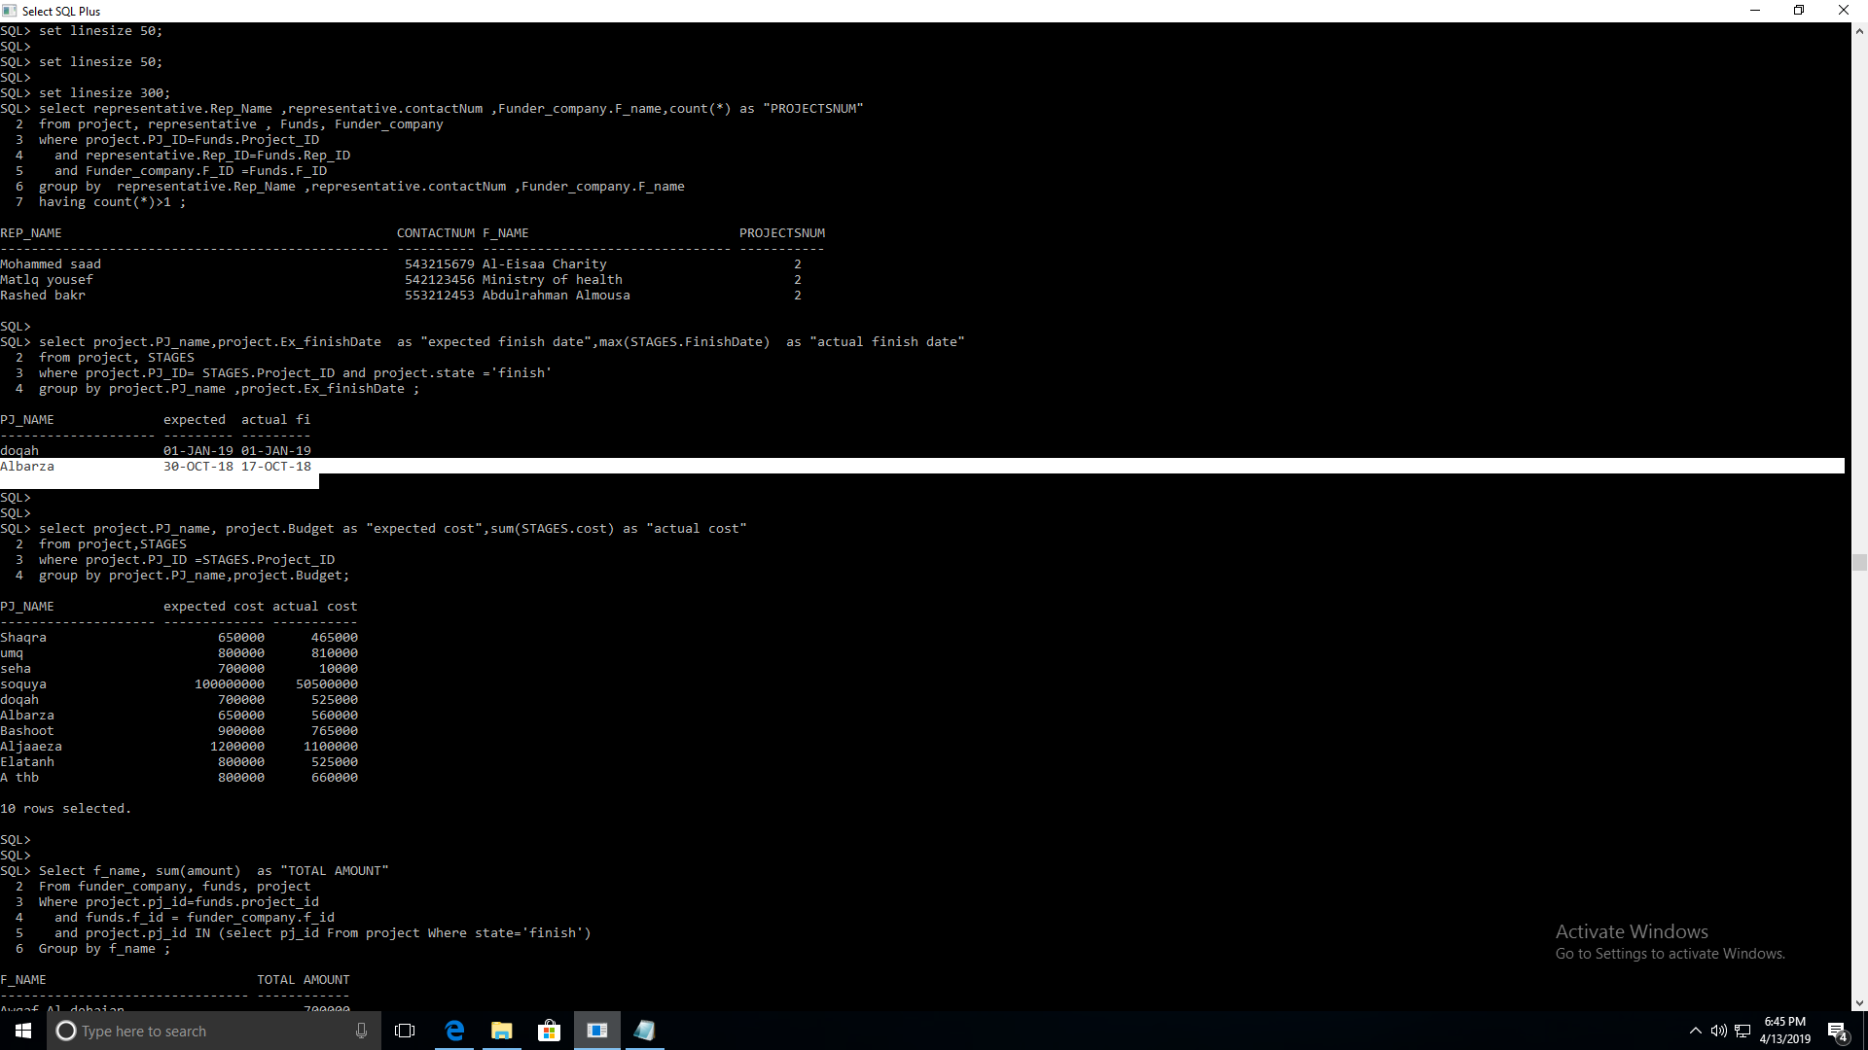

## 8.4 *<* *Funder company/companies of* finished projects *>*

**Query in natural language (ENGLISH)**

For each finished project print Funder company*/companies* Name and its total funds.

**SQL script**

Select f_name, sum(amount) as "TOTAL AMOUNT"

From funder_company, funds, project

Where project.pj_id=funds.project_id

and funds.f_id = funder_company.f_id

and project.pj_id IN (select pj_id from project Where state='finish')

Group by f_name ;

**Caption of the first five rows of the output**

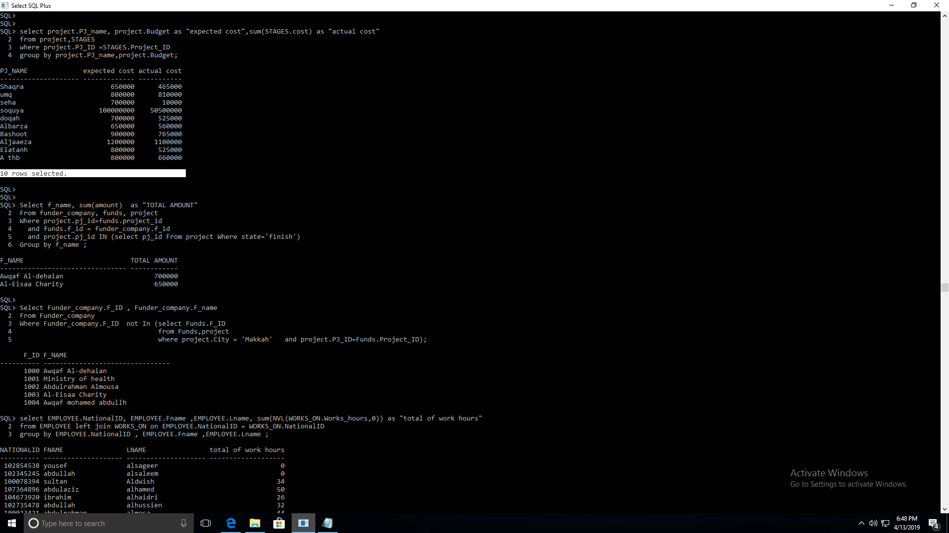

## 8.5 *< Funder companies of projects except ‘*Makkah’ projects *>*

**Query in natural language (ENGLISH)**

Print the ID and Name of each Funder Company that Funds a project not in ‘Makkah’ city .

**SQL script**

Select Funder_company.F_ID , Funder_company.F_name

From Funder_company

Where Funder_company.F_ID not In (select Funds.F_ID

from Funds,project

where project.City = 'Makkah'

and project.PJ_ID=Funds.Project_ID);

**Caption of the first five rows of the output**

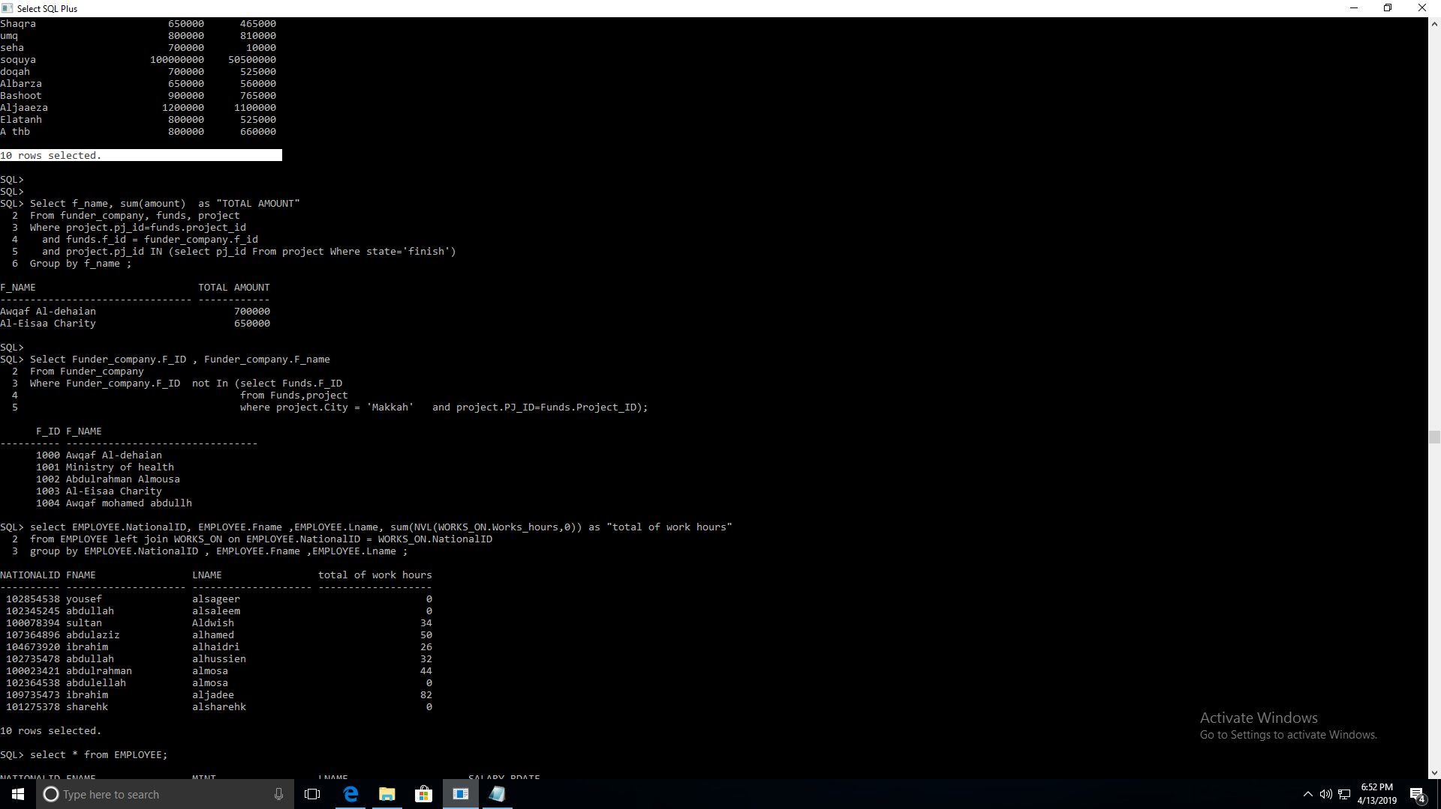

## 8.6 *<* *Work hours of each* employee *>*

**Query in natural language (ENGLISH)**

For each employee, print the NationalID, employees’ firstName and LastNames, and the total number of its work hours,

(include even employees who did works on project).

**SQL script**

select EMPLOYEE.NationalID, EMPLOYEE.Fname ,EMPLOYEE.Lname, sum(NVL(WORKS_ON.Works_hours,0)) as "total of work hours"

from EMPLOYEE left join WORKS_ON on EMPLOYEE.NationalID = WORKS_ON.NationalID

group by EMPLOYEE.NationalID , EMPLOYEE.Fname ,EMPLOYEE.Lname ;

**Caption of the first five rows of the output**



# APPENDIX

Employee

|  |  |  |  |  |  |  |  |  |
| --- | --- | --- | --- | --- | --- | --- | --- | --- |
| National ID | Fname | Mint | Lname | Salary | Bdate | Notes | DPID | SupervisorID |
| 100023421 | abdulrahman | saad | almosa | 15,000 | 1972-07-31 | 'A businessman interested to support charity' | 001 | 100023421 |
| 102345245 | abdullah | yehia | alsaleem | 10,000 | 1983-03-29 | 'Specializes in management, asset management' | 001 | 102345245 |
| 100078394 | sultan | mohamed | Aldwish | 7,000 | 1990-05-31 | 'Specializes in management, asset management' | 002 | 102345245 |
| 102735478 | abdullah | saleh | alhussien | 6.500 | 1976-08-23 | 'Specializes in management, asset management' | 001 | 102345245 |
| 107364896 | abdulaziz | abdullah | alhamed | 6,000 | 1986-08-18 | 'An academic specializing in water resources engineering and hydraulics' | 003 | 102345245 |
| 102364538 | abdulellah | abdulaziz | almosa | 6,000 | 1984-05-30 | 'A businessman interested to support charity' | 001 | 102345245 |
| 109735473 | ibrahim | saad | aljadee | 9,000 | 1987-05-10 | 'An academic specializing in environmental engineering, water treatment and distribution. | 001 | 109735473 |
| 104673920 | yousef | saleh | alsageer | 8,560 | 1972-03-31 | An academic and inventor in chemical engineering and interested in charity work. | 003 | 109735473 |
| 104673920 | ibrahim | suliman | alhaidri | 8,500 | 1989-07-05 | An academic specializing in management and marketing, and interested in charity work | 001 | 100023421 |
| 101275378 | sharehk | ibrahim | alsharehk | 9,000 | 1981-07-09 | specializes in chemical engineering and interested in charity work | 002 | 100023421 |

Works_ON

|  |  |  |
| --- | --- | --- |
| Works_hours | Project ID | National ID |
| 34 | 1 | 100078394 |
| 32 | 2 | 102735478 |
| 30 | 1 | 109735473 |
| 26 | 2 | 104673920 |
| 30 | 3 | 109735473 |
| 10 | 4 | 107364896 |
| 40 | 6 | 107364896 |
| 22 | 2 | 109735473 |
| 22 | 2 | 100023421 |
| 22 | 5 | 100023421 |

Department

|  |  |  |
| --- | --- | --- |
| DP_ID | DP_name | Manger_ID |
| 1 | Administration | 100023421 |
| 2 | executive | 102345245 |
| 3 | Financial | 109735473 |

representative

|  |  |  |  |
| --- | --- | --- | --- |
| Rep_ID | Rep_Name | contactNum | FunderID |
| 121234 | Saeed saleh | 0543212340 | 1000 |
| 135235 | Mohammad ahmad | 0542165951 | 1000 |
| 121289 | Abdullah alshareef | 0543217040 | 1000 |
| 121235 | Matlq yousef | 0542123456 | 1001 |
| 121236 | Rashed bakr | 0553212453 | 1002 |
| 121263 | Ahmed salem | 0553213201 | 1002 |
| 121238 | Mohammed saad | 0543215679 | 1003 |
| 121898 | Yaser selyman | 0543211239 | 1004 |
| 121210 | yheya asead | 0543213219 | 1001 |
| 121321 | soltan hamdan | 0543217859 | 1004 |

Project

|  |  |  |  |  |  |  |  |  |
| --- | --- | --- | --- | --- | --- | --- | --- | --- |
| PJ_ID | PJ_name | Ex_startDate | Ex_finishDate | state | Budget | Region | City | Province |
| 1 | soquya | 2018-07-31 | 2019-05-23 | In-progress | 100,000,000 | Makkah | Jeddah | Jeddah |
| 2 | A'thb | 2018-05-01 | 2019-09-31 | In-progress | 800,000 | Sabt al-alayah | aseer | Sabt  al-alayah |
| 3 | doqah | 2018-08-13 | 2019-01-01 | finish | 700,000 | doqah | alqunfothah | makkah |
| 4 | Albarza | 2017-12-31 | 2018-10-30 | finish | 650,000 | Makkah | Makkah | Makkah |
| 5 | Shaqra | 2018-02-26 | 2019-12-16 | In-progress | 650,000 | Riyadh | Shaqra | Riyadh |
| 6 | Alja’aeza | 2018-01-01 | 2020-01-01 | In-progress | 1,200,000 | Makkah | Addam | Alja’aeza |
| 7 | Bashoot | 2018-02-20 | 2021-10-15 | In-progress | 900,000 | Sabt al-alayah | aseer | bashoot |
| 8 | umq | 2018-02-19 | 2020-10-03 | In-progress | 800,000 | tabook | umlj | umq |
| 9 | Ela'tanh | 2018-05-10 | 2026-10-16 | In-progress | 800,000 | Makkah | Alleth | alrahuah |
| 10 | seha | 2018-01-22 | 2024-10-27 | In-progress | 700,000 | Riyadh | Riyadh | Riyadh |

Funder_company

|  |  |
| --- | --- |
| F_ID | F_name |
| 1000 | Awqaf Al-dehaian |
| 1001 | Ministry of health |
| 1002 | Abdulrahman Almousa |
| 1003 | Al-Eisaa Charity |
| 1004 | A wqaf mohamed abdullh |

Funds

|  |  |  |  |
| --- | --- | --- | --- |
| Project_ID | F_ID | amount | Rep_ID |
| 1 | 1000 | 100,000,000 | 121234 |
| 2 | 1002 | 800,000 | 121236 |
| 3 | 1000 | 700,000 | 121234 |
| 4 | 1003 | 650,000 | 121238 |
| 5 | 1001 | 650,000 | 121235 |
| 6 | 1001 | 1,200,000 | 121235 |
| 7 | 1002 | 900,000 | 121236 |
| 8 | 1002 | 800,000 | 121236 |
| 9 | 1000 | 800,000 | 121234 |
| 10 | 1003 | 700,000 | 121238 |

Bank_Acount

|  |  |  |
| --- | --- | --- |
| B_ID | B_name | IPAN |
| 12983322 | Alahli bank | 3704 0044 0532 0130 00 |
| 12983324 | Alrajhi bank | 4567 0076 0274 0430 00 |

Project_bankAccount

|  |  |
| --- | --- |
| B_ID | Pj_ID |
| 12983322 | 1 |
| 12983324 | 2 |
| 12983324 | 3 |
| 12983324 | 4 |
| 12983322 | 5 |
| 12983322 | 6 |
| 12983324 | 7 |
| 12983322 | 8 |
| 12983322 | 9 |
| 12983324 | 10 |

|  |  |  |  |  |  |
| --- | --- | --- | --- | --- | --- |
| Project_ID | S_id | S_name | StartDate | FinishDate | cost |
| 1 | 1 | planning | 2018-07-31 | 2018-08-31 | 500,000 |
| 1 | 2 | construction | 2018-09-01 | null | 50000000 |
| 2 | 1 | planning | 2018-05-14 | 2018-08-28 | 10000 |
| 2 | 2 | construction | 2018-08-29 | 2019-04-21 | 650000 |
| 3 | 1 | planning | 2018-08-13 | 2018-08-28 | 10000 |
| 3 | 2 | construction | 2018-09-02 | 2018-12-12 | 500000 |
| 3 | 3 | tests | 2018-12-29 | 2019-01-01 | 15000 |
| 4 | 1 | planning | 2017-12-31 | 2018-01-29 | 100000 |
| 4 | 2 | construction | 2018-02-02 | 2018-10-01 | 450000 |
| 4 | 3 | tests | 2018-10-02 | 2018-10-17 | 10000 |
| 5 | 1 | planning | 2018-02-20 | 2018-03-03 | 15000 |
| 5 | 2 | construction | 2018-04-21 | null | 450000 |
| 6 | 1 | planning | 2018-01-01 | 2018-02-01 | 100000 |
| 6 | 2 | construction | 2018-03-01 | null | 1000000 |
| 7 | 1 | planning | 2018-02-20 | 2018-03-21 | 15000 |
| 7 | 2 | construction | 2018-04-21 | null | 750000 |
| 8 | 1 | planning | 2018-02-19 | 2018-02-29 | 20000 |
| 8 | 2 | construction | 2018-03-03 | null | 790000 |
| 9 | 1 | planning | 2018-05-10 | 2018-05-25 | 25000 |
| 9 | 2 | construction | 2019-02-22 | null | 500000 |
| 10 | 1 | planning | 2018-01-22 | 2018-02-09 | 10000 |

Stages

Executive_company

|  |  |  |
| --- | --- | --- |
| EC_ID | EC_name | Ex_contactNum |
| 1 | Saudi Amana Contracting | 0128735444 |
| 2 | Al-rajhi constructing company | 01266574737 |
| 3 | SACODE CO | 0555566678 |
| 4 | MAPA constructing company | 0118743322 |
| 5 | AL-wadi for design and planning | 0598777777 |
| 6 | Medina united comapny | 0117654567 |
| 7 | Alfadel company construction | 0123456789 |
| 8 | Bena usakan constructing company | 9009007678 |
| 9 | Al-Dar constructions | 9000070000 |
| 10 | KOOB water solution | 0113333344 |

INSERT INTO EMPLOYEE VALUES (100023421,'abdulrahman', 'saad','almosa',15000 ,to_date('1972-07-31','yyyy-mm-dd') ,'A businessman interested to support charity',001, 109735473);

INSERT INTO EMPLOYEE VALUES (102345245,'abdullah' ,'yehia','alsaleem',10000, to_date('1983-03-29','yyyy-mm-dd') ,'Specializes in management, asset management',001, 109735473);

INSERT INTO EMPLOYEE VALUES (100078394,'sultan' ,'mohamed' ,'Aldwish' ,7000 ,to_date('1990-05-31','yyyy-mm-dd') ,'A specialist in management and marketing, interested in charity work',002, 102345245);

INSERT INTO EMPLOYEE VALUES (102735478,'abdullah', 'saleh' , 'alhussien' ,6500 ,to_date('1976-08-23','yyyy-mm-dd'),'An academic in architecture, interested in charity work', 001,102345245);

INSERT INTO EMPLOYEE VALUES (107364896,'abdulaziz' , 'abdullah', 'alhamed',6000,to_date('1986-08-18','yyyy-mm-dd'),'An academic specializing in water resources engineering and hydraulics', 003,102345245);

INSERT INTO EMPLOYEE VALUES (102364538,'abdulellah' , 'abdulaziz', 'almosa' ,6000 ,to_date('1984-05-30','yyyy-mm-dd'),'A businessman interested to support charity',001,102345245);

INSERT INTO EMPLOYEE VALUES (109735473,'ibrahim','saad','aljadee' ,9000,to_date('1987-05-10','yyyy-mm-dd') , 'An academic specializing in environmental engineering, water treatment and distribution.',001 ,100023421);

INSERT INTO EMPLOYEE VALUES (102854538,'yousef','saleh','alsageer', 8560 ,to_date('1972-03-31','yyyy-mm-dd'),'An academic and inventor in chemical engineering, and interested in charity work.',003,109735473);

INSERT INTO EMPLOYEE VALUES (104673920,'ibrahim' ,'suliman','alhaidri' ,8500 ,to_date('1989-07-05','yyyy-mm-dd'),'An academic specializing in management and marketing, and interested in charity work',001,100023421);

INSERT INTO EMPLOYEE VALUES (101275378,'sharehk' ,'ibrahim' , 'alsharehk' ,9000 ,to_date('1981-07-09','yyyy-mm-dd'),'a specializes in chemical engineering and interested in charity work', 002,100023421);

INSERT INTO Department VALUES (001 ,'Administration', 100023421);

INSERT INTO Department VALUES (002 ,'executive', 102345245);

INSERT INTO Department VALUES (003 ,'Financial', 109735473);

CREATE SEQUENCE seq_PJ START WITH 0 INCREMENT BY 1 minvalue 0 ;

INSERT INTO Project VALUES (seq_PJ.Nextval,'soquya',to_date('2018-07-31','yyyy-mm-dd'),to_date('2019-05-23','yyyy-mm-dd'),'In-progress', 100000000,'Makkah','Jeddah','Jeddah');

INSERT INTO Project VALUES (seq_PJ.Nextval, 'A thb',to_date('2018-05-01','yyyy-mm-dd'),to_date('2019-09-29','yyyy-mm-dd') , 'In-progress', 800000 ,'aseer','Sabt al-alayah', 'Sabt al-alayah');

INSERT INTO Project VALUES (seq_PJ.Nextval, 'doqah', to_date('2018-08-13','yyyy-mm-dd') , to_date('2019-01-01','yyyy-mm-dd') ,'finish', 700000, 'makkah' ,'doqah' ,'alqunfothah');

INSERT INTO Project VALUES (seq_PJ.Nextval, 'Albarza' , to_date('2017-12-31','yyyy-mm-dd'),to_date('2018-10-30','yyyy-mm-dd') ,'finish' , 650000 , 'Makkah' ,'Albarza','helas' );

INSERT INTO Project VALUES (seq_PJ.Nextval, 'Shaqra', to_date('2018-02-26','yyyy-mm-dd'),to_date('2019-12-16','yyyy-mm-dd'), 'In-progress', 650000, 'Riyadh','Shaqra','Riyadh' );

INSERT INTO Project VALUES (seq_PJ.Nextval, 'Aljaaeza' , to_date('2018-01-01','yyyy-mm-dd'),to_date('2020-01-01','yyyy-mm-dd'),'In-progress', 1200000,'Makkah', 'Aljaaeza' ,'Addam' );

INSERT INTO Project VALUES (seq_PJ.Nextval, 'Bashoot' ,to_date('2018-02-20','yyyy-mm-dd') ,to_date('2021-10-15','yyyy-mm-dd'), 'In-progress' ,900000,'aseer', 'bashoot' ,'Sabt al-alayah');

INSERT INTO Project VALUES (seq_PJ.Nextval, 'umq' , to_date('2018-02-19','yyyy-mm-dd'), to_date('2020-10-03','yyyy-mm-dd') ,'In-progress' ,800000,'tabook', 'umq','umlj' );

INSERT INTO Project VALUES (seq_PJ.Nextval, 'Elatanh' ,to_date('2018-05-10','yyyy-mm-dd') ,to_date('2026-10-16','yyyy-mm-dd'),'In-progress' ,800000 ,'Makkah' ,'alrahuah' ,'Alleth');

INSERT INTO Project VALUES (seq_PJ.Nextval,'seha',to_date('2018-01-22','yyyy-mm-dd'),to_date('2024-10-27','yyyy-mm-dd'),'In-progress', 700000,'Riyadh','Riyadh','Riyadh');

INSERT INTO Works_ON VALUES (34,1, 100078394);

INSERT INTO Works_ON VALUES (32,2, 102735478);

INSERT INTO Works_ON VALUES (30,1, 109735473);

INSERT INTO Works_ON VALUES (26,2, 104673920);

INSERT INTO Works_ON VALUES (30,3, 109735473);

INSERT INTO Works_ON VALUES (10,4, 107364896);

INSERT INTO Works_ON VALUES (40,6, 107364896);

INSERT INTO Works_ON VALUES (22,2, 109735473);

INSERT INTO Works_ON VALUES (22,2, 100023421);

INSERT INTO Works_ON VALUES (22,5, 100023421);

CREATE SEQUENCE seq_FC START WITH 999 INCREMENT BY 1;

INSERT INTO Funder_company VALUES (seq_FC.Nextval ,'Awqaf Al-dehaian');

INSERT INTO Funder_company VALUES (seq_FC.Nextval ,'Ministry of health');

INSERT INTO Funder_company VALUES (seq_FC.Nextval ,'Abdulrahman Almousa');

INSERT INTO Funder_company VALUES (seq_FC.Nextval ,'Al-Eisaa Charity');INSERT INTO Funder_company VALUES (seq_FC.Nextval ,'Awqaf mohamed abdullh');

INSERT INTO representative VALUES (121234,'Saeed saleh', 0543212340,1000);

INSERT INTO representative VALUES (135235,'mohammed ahmed', 0542165951,1000);

INSERT INTO representative VALUES (121289,'abdullah alshareef', 0543217040,1000);

INSERT INTO representative VALUES (121235,'Matlq yousef', 0542123456,1001);

INSERT INTO representative VALUES (121236,'Rashed bakr', 0553212453, 1002);

INSERT INTO representative VALUES (121263,'ahmed salem', 0553213201, 1002);

INSERT INTO representative VALUES (121238,'Mohammed saad', 0543215679, 1003);INSERT INTO representative VALUES (121898,'yaser selyman', 0543211239, 1004);

INSERT INTO representative VALUES (121210,'yheya asead', 0543213219, 1001);

INSERT INTO representative VALUES (121321,'soltan hamdan', 0543217859, 1004);

INSERT INTO Funds VALUES( 1,1000, 100000000,121234);

INSERT INTO Funds VALUES( 2,1002, 800000,121263);

INSERT INTO Funds VALUES( 3,1000, 700000,135235);

INSERT INTO Funds VALUES( 4,1003, 650000,121238);

INSERT INTO Funds VALUES( 5,1001, 650000,121235);

INSERT INTO Funds VALUES( 6,1001, 1200000,121235);

INSERT INTO Funds VALUES( 7,1002, 900000,121236);

INSERT INTO Funds VALUES( 8,1002, 800000,121236);

INSERT INTO Funds VALUES( 9,1000, 800000,121289);

INSERT INTO Funds VALUES( 10,1003, 700000,121238);

INSERT INTO Bank_Acount VALUES (12983322,'Alahli bank', '3704 0044 0532 0130 00');

INSERT INTO Bank_Acount VALUES (12983324,'Alrajhi bank', '4567 0076 0274 0430 00');

INSERT INTO Project_bankAccount VALUES (12983322,1);

INSERT INTO Project_bankAccount VALUES (12983324,2);

INSERT INTO Project_bankAccount VALUES (12983324,3);

INSERT INTO Project_bankAccount VALUES (12983324,4);

INSERT INTO Project_bankAccount VALUES (12983322,5);

INSERT INTO Project_bankAccount VALUES (12983322,6);

INSERT INTO Project_bankAccount VALUES (12983324,7);

INSERT INTO Project_bankAccount VALUES (12983322,8);

INSERT INTO Project_bankAccount VALUES (12983322,9);

INSERT INTO Project_bankAccount VALUES (12983324,10);

CREATE SEQUENCE ec_seq START WITH 0 INCREMENT BY 1 minvalue 0;

INSERT INTO Executive_company VALUES( ec_seq.nextval ,'Saudi Amana Contracting', '0128735444' );

INSERT INTO Executive_company VALUES( ec_seq.nextval , 'Al-rajhi constructing company', '01266574737' );

INSERT INTO Executive_company VALUES( ec_seq.nextval , 'SACODE CO', '0555566678' );

INSERT INTO Executive_company VALUES( ec_seq.nextval , 'MAPA constructing company', '0118743322');

INSERT INTO Executive_company VALUES( ec_seq.nextval , 'AL-wadi for design and planning' , '0598777777' );

INSERT INTO Executive_company VALUES( ec_seq.nextval , 'Medina united comapny' , '0117654567' );

INSERT INTO Executive_company VALUES( ec_seq.nextval , 'Alfadel company construction ', '0123456789' );

INSERT INTO Executive_company VALUES( ec_seq.nextval , 'Bena usakan constructing company', '9009007678' );

INSERT INTO Executive_company VALUES( ec_seq.nextval , 'Al-Dar constructions', '9000070000' );

INSERT INTO Executive_company VALUES( ec_seq.nextval , 'KOOB water solutions', '0113333344' );

INSERT INTO Stages VALUES(1, 5, 1, 'planning',to_date('2018-07-31','yyyy-mm-dd'),to_date('2018-08-31','yyyy-mm-dd') ,500000);

INSERT INTO Stages VALUES(1, 2, 2,'construction', to_date('2018-09-01','yyyy-mm-dd'),null , 50000000);

INSERT INTO Stages VALUES(2, 5, 1, 'planning' ,to_date('2018-05-14','yyyy-mm-dd'),to_date('2018-08-28','yyyy-mm-dd') , 10000);

INSERT INTO Stages VALUES(2, 2, 2, 'construction' , to_date('2018-08-29','yyyy-mm-dd'),to_date('2019-04-21','yyyy-mm-dd') , 650000);

INSERT INTO Stages VALUES(3, 5, 1, 'planning' ,to_date('2018-08-13','yyyy-mm-dd'),to_date('2018-08-28','yyyy-mm-dd') , 10000);

INSERT INTO Stages VALUES(3, 8, 2, 'construction' , to_date('2018-09-02','yyyy-mm-dd'),to_date('2018-12-12','yyyy-mm-dd') , 500000);

INSERT INTO Stages VALUES(3, 10, 3, 'tests' , to_date('2018-12-29','yyyy-mm-dd'),to_date('2019-01-01','yyyy-mm-dd'), 15000);

INSERT INTO Stages VALUES(4, 5, 1, 'planning' ,to_date('2017-12-31','yyyy-mm-dd'),to_date('2018-01-29','yyyy-mm-dd') , 100000);

INSERT INTO Stages VALUES(4, 9, 2, 'construction' , to_date('2018-02-02','yyyy-mm-dd'),to_date('2018-10-01','yyyy-mm-dd') , 450000);

INSERT INTO Stages VALUES(4, 10, 3, 'tests' , to_date('2018-10-02','yyyy-mm-dd'),to_date('2018-10-17','yyyy-mm-dd'), 10000);

INSERT INTO Stages VALUES(5, 5, 1, 'planning' ,to_date('2018-02-20','yyyy-mm-dd'),to_date('2018-03-03','yyyy-mm-dd') , 15000);

INSERT INTO Stages VALUES(5, 6, 2, 'construction' , to_date('2018-04-21','yyyy-mm-dd'),null , 450000);

INSERT INTO Stages VALUES(6, 5, 1, 'planning' ,to_date('2018-01-01','yyyy-mm-dd'),to_date('2018-02-01','yyyy-mm-dd') , 100000);

INSERT INTO Stages VALUES(6, 7, 2, 'construction' , to_date('2018-03-01','yyyy-mm-dd'),null , 1000000);

INSERT INTO Stages VALUES(7, 5, 1, 'planning' ,to_date('2018-02-20','yyyy-mm-dd'),to_date('2018-03-21','yyyy-mm-dd') , 15000);

INSERT INTO Stages VALUES(7, 7, 2, 'construction' , to_date('2018-04-21','yyyy-mm-dd'), null , 750000);

INSERT INTO Stages VALUES(8, 5, 1, 'planning' ,to_date('2018-02-19','yyyy-mm-dd'),to_date('2018-02-28','yyyy-mm-dd') , 20000);

INSERT INTO Stages VALUES(8, 2, 2, 'construction' , to_date('2018-03-03','yyyy-mm-dd'),null , 790000);

INSERT INTO Stages VALUES(9, 5, 1, 'planning' ,to_date('2018-05-10','yyyy-mm-dd'),to_date('2018-05-25','yyyy-mm-dd') , 25000);

INSERT INTO Stages VALUES(9, 4, 2, 'construction' , to_date('2019-02-22','yyyy-mm-dd'),null , 500000);

INSERT INTO Stages VALUES(10, 5, 1, 'planning' ,to_date('2018-01-22','yyyy-mm-dd'),to_date('2018-02-09','yyyy-mm-dd') , 10000);